Windham County, Vermont
Successful Aging
Community Study

August 2007

Prepared for the
Windham Regional Healthy Aging Steering Committee

Funded by: United Way of Windham County,
the Thomas Thompson Trust & the Council on Aging
for Southeastern Vermont,Inc.

TMF | The Medical Foundation

95 Berkeley Street
Boston, Massachusetts 02116
617-451-0049
www.tmfnet.org
Table of Contents

Introduction 3
I. BACKGROUND 5
III. STUDY FINDINGS 7
A. COMMUNITY PROFILE 7
1. Location 7
2. Demographics 8
3. Racial/Ethnic Distribution 19
4. Land Development Patterns 20
5. Social Environment 21
B. ECONOMIC INDICATORS 24
1. Employment 24
2. Income and Poverty Status 27
3. Housing 31
4. Housing Costs 33
C. TRANSPORTATION 36
1. Commuting 37
2. Public Transportation 38
3. Walking 39
D. CRIME 40
E. EDUCATION 41
1. Literacy 41
2. Educational Attainment 41
3. Opportunities for Education/Training 42
F. HEALTH AND HUMAN SERVICES 43
1. Health/Human Service Indicators 43
2. Health Care Access 47
3. Human Services 52
IV. VISION FOR THE FUTURE OF WINDHAM COUNTY 55
V. RECOMMENDED NEXT STEPS 57
Appendix I: Advisory Group 61
Appendix II: Sources of Secondary/Existing Data 62
Appendix III: Windham County Community Survey 63
Appendix IV: Windham County Area Survey Summary Tables 70
Appendix V: Interview and Focus Group Guide 74
Appendix VI: Interview and Focus Group Participants 77
Appendix VII: Vision Statements from Focus Groups and Interviews 80

Windham County, Vermont
Successful Aging Community Study
August 2007

Introduction

In 2004, the Windham County Long Term Care Network established a subgroup, the Windham Regional Healthy Aging Steering Committee (WRHASC). The charges for this committee were to:

- conduct an assessment of state and local data including an examination of the needs and available resources for an aging population within the area;
- create a vision of a livable and viable community for all, particularly the aging population; and
- develop an action plan to meet the continuing needs of the aging population in the Windham County area.

In 2006, the committee contracted with The Medical Foundation (TMF) to conduct a countywide study to examine issues relating to the aging population. The study, completed in May 2007, included three components:

- a quantitative analysis of regional demographic, health, and social indicators, including comparisons to state and national statistics;
- a quantitative community survey of opinions and priorities of local residents; and
- a qualitative assessment via focus groups and interviews of individuals representing a broad cross-section of the community.

Key Findings

It is important to note that this assessment is a snapshot of the existing conditions in 2006-2007. While participants were asked to envision the future, no one can fully predict the impact of the socio-economic and demographic changes – including the dramatic increase of individuals 65 and older - in Windham County. There are many positive benefits of an increasing proportion of aging residents in the region. Yet, the following challenges should remain at the forefront of all planning and outreach:

- There will be a dramatic rise in the aging population in the next 15-30 years. The next generation, of smaller population size, will be asked to provide an increased variety of support for their elders.
- Increased support will require significantly greater regional contributions of time, money and other resources to cover growing support and costs associated with elders’ needs.
- This intergenerational balance of need and support will be a significant social and financial issue in the 21st century in this community and nationally.
- The current and future availability of appropriate assisted living and nursing home facilities is a matter of serious concern to a majority of county residents. While the Vermont Choices for Care program has increased the choices available for Medicaid recipients, there are inadequate resources for handling the increased regional demand for such services in the future.
- The lack of affordable and appropriate housing is a serious problem for elderly residents of Windham County. Although the State of Vermont identified housing affordability as a significant problem over twenty years ago and has taken some steps to address the issue, the problem remains as serious, or more so, than ever, and current state and federal budget constraints and priorities have resulted in reductions in funding for housing programs.
- Public and volunteer transportation in the region consists of a fragile set of scattered services to a geographically dispersed population. These services are struggling for funding just to maintain fixed route public transportation at current levels. As current trends continue, the need for such services will increase.

BACKGROUND

In 2004, the Windham County Long Term Care Network established a subgroup, the Windham Regional Healthy Aging Steering Committee. The Committee represents a range of interests including consumers, advocates, providers, and other dedicated individuals. The charges for this committee were to:
- conduct an assessment of state and local data including an examination of the needs and available resources for an aging population within the area;
- create a vision of a livable and viable community for all, particularly the aging population; and
- develop an action plan to meet the continuing needs of the aging population in the Windham County area.
In thinking about developing a plan to improve the quality of life for the older adult population of Windham County two main issues guided the group’s discussion. First, elder services and long term care needs will have growing, and ultimately profound, impact on Windham County individuals and communities; and these communities do not yet comprehend the full magnitude or extent of this impact. Second, Windham County, like the State of Vermont as a whole, lacks the information needed to implement a comprehensive approach to meeting long-term care needs – an approach service providers and the public will have confidence in and will support
In 2006, the committee contracted with The Medical Foundation (TMF) to conduct a countywide study to examine issues relating to the aging population. This study examined a broad range of demographic, economic, education, health and social factors that impact the lives of individuals, families, and institutions within the area. The study findings will be shared with individuals and organizations serving Windham County so they may develop a plan to create a livable and viable community and meet the continuing, growing needs of the aging population in Windham County. Funding for this study was provided to the Council on Aging for Southeastern Vermont by the United Way of Windham County and the Thomas Thompson Trust.

STUDY METHODOLOGY
To conduct this study, TMF used a participatory community assessment process that included quantitative and qualitative data collection and analyses. The geographic focus of the study is Windham County, Vermont. The study methods were guided and informed by an 11 member Advisory Group. A list of members is provided in Appendix I.
Quantitative Information
The first part of the quantitative analyses included numerical representations of various demographic, health, and social indicators of the communities in Windham County in comparison to the state and country as a whole. The majority of the data is reported for one point in time, but where relevant, data are documented over time. Appendix II contains a list of national, state, county, and town data sources that were utilized. Examples include the U.S. Census Bureau, U.S. Bureau of Labor Statistics, U.S. Department of Justice, United Health Foundation, Vermont Department of Labor, Vermont Department of Taxes, Vermont Department of Housing and Community Affairs, and Vermont Agency of Human Services. Because of the variety of data sources utilized, data are presented by the State of Vermont, Windham County, or town when available.
A second component of the quantitative data was a community survey that recorded respondents’ opinions regarding various aspects of living in Windham County and priorities for the area. A copy of this survey is provided in Appendix III. Respondents are from a convenience sample rather than a random sample. The survey was available as a self-administered, paper and pencil questionnaire, as well as available on the Internet to individuals in their homes or at community-based locations such as senior centers and public libraries. The total number of survey respondents was 336. Of this total, 328 respondents reside in the geographic area of focus for this study; eight respondents reside in other areas with ties to the Windham County. For the purposes of this report, only data from the 328 respondents are discussed. Of these 328 respondents, the majority were: female (70%), with an average age of 67 years, white, non-Hispanic (98.8%), married (48.6%) or widowed (21.8%), retired (61.4%), live in their own home (66.2%), and have lived in Windham County, for an average of 35 years. A little more than one half of the survey respondents (53.9%) are living on an income of less than $35,000 annually, with an average of two people being supported by this income. The primary source of income for survey respondents is Social Security benefits (61.6%), though many of these same respondents reported other sources of support as well, including wages, savings, and pensions. Detailed demographic tables of the respondents are provided in Appendix IV. Throughout the report narrative, the survey question results are included within the appropriate topic area, as are selected anonymous comments from open-ended survey questions.

Qualitative Information
The purpose of the qualitative data collection was to add a context to the quantitative data by including the voice of community leaders and residents regarding the current assets, needs, and resources of the Windham County area. Qualitative information was gathered through a series of 13 focus groups and interviews with five key informants (a total of 145 individuals). Participants in the focus groups and interviews included representatives of area nonprofits, community-based organizations; health and medical providers; local businesses; elected officials; planners; community leaders; and private citizens. Youth, working age adults, and senior citizens were also represented.
Each focus group was facilitated by TMF staff or trained volunteers utilizing a focus group guide to ensure consistency across groups. One staff member or volunteer facilitated each discussion, while another staff member or volunteer took detailed notes of the conversation. On average, focus groups were 90 minutes in length. Interviews were conducted in person or via telephone and lasted approximately 30 to 60 minutes. Each interview was conducted using an interview guide to ensure consistency across interviews. The collected information was analyzed thematically, looking for similarities and differences across responses. A copy of the focus group and interview guide is provided in Appendix V and a complete listing of the participants in the focus groups and interviews is provided in Appendix VI. Selected quotes – without personal identifying information – are presented in the narrative of this report to further illustrate points within topic areas.

STUDY FINDINGS

COMMUNITY PROFILE
This section of the report provides a community profile of Windham County, including its location, demographic composition, cultural diversity, and social environment.

Location
Windham County, highlighted in red in Figure 1, is one of fourteen counties in Vermont and is the Southeastern-most county in the State. Vermont, with an area of 9,614 square miles, is the 5th smallest state in the United States. Windham County’s 798 square miles are comprised of 789 square miles of land and 9 square miles of water and account for approximately 8.3% of the total area in the State. It is bordered to the North by Windsor County, Vermont, to the Northeast by Sullivan County, New Hampshire, to the East by Cheshire County, New Hampshire, to the South by Franklin County, Massachusetts, and to the West by Bennington County, Vermont. The largest town in Windham County is Brattleboro, which is located in the southeast area of the County.
Figure 1: Map of the State of Vermont
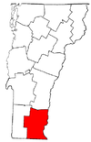

Participants in the community assessment identified the “rural nature” and “beautiful, natural surroundings” of the Windham County area as an asset. The area contains numerous state and local parks, preserved and undeveloped areas. These sites offer a wide variety of recreational activities, including camping, mountain biking, walking, hiking, boating, birding, and fishing.

Demographics
This section of the report focuses on population trends in Windham County. All data reported here are from the 2000 U.S. Census Bureau unless otherwise indicated.

Individuals
Table 1 is a population profile of towns in Windham County. In 2000, the total population of Windham County was 44,216. According to U.S. Census data in 2000, the most heavily populated town in this area is Brattleboro, with a population of 12,005. Approximately 27% of Windham County inhabitants resided there. The smallest town was Somerset, which had a population of five.

Table 1: Population of Windham County, 2000
 | Population
Windham County, Specific Towns
Brattleboro town | 12,005
Rockingham, including the Village of Bellows Falls | 5,309
Westminster town | 3,210
Putney town | 2,634
Wilmington town | 2,225
Vernon town | 2,141
Guilford town | 2,046
Dummerston town | 1,915
Londonderry town | 1,709
Newfane town | 1,680
Dover town | 1,410
Whitingham town | 1,298
Townshend town | 1,149
Marlboro town | 978
Jamaica town | 946
Wardsboro town | 854
Halifax town | 782
Grafton town | 649
Brookline town | 467
Athens town | 340
Windham town | 328
Stratton town | 136
Somerset town | 5
Total Population | 44,216
Source: U.S. Census Bureau, 2000

Figure 2 illustrates population trends for the Windham County area from 1990 to 2000. The population of Windham County alone increased 6.3% during this ten-year period, compared to increases of 8.2% statewide in Vermont and 13.2% nationwide. Twenty of the towns in the geographic focus area for this study experienced population increases and two towns experienced decreases during this same time period. The largest increase, 41.9%, was seen in Dover. The largest decrease (3.2%) occurred in Rockingham, which includes the Village of Bellows Falls. Also of note is that the County’s largest town, Brattleboro, documented a 1.9% decrease in population.

Figure 2: Population Change in Windham County, 1990 to 2000
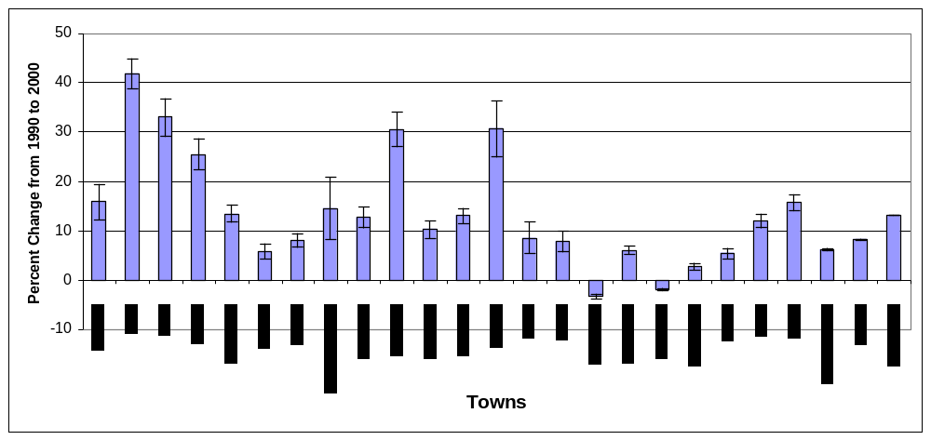
Source: U.S. Census Bureau, 2000

In the 2000 Census, 76.5% of the Windham County population was 18 years old or older, slightly higher than Vermont (75.8%) and the United States (74.3%). As seen in Figure 3, of this adult population, individuals 25 to 44 years old account for 36.8% of the population in Windham County, lower than that of Vermont (38.3%) and the United States (40.7%).

Figure 3: Percentage of Adult Population 18 to 24 Years Old and 25 to 44 Years Old in Windham County, 2000
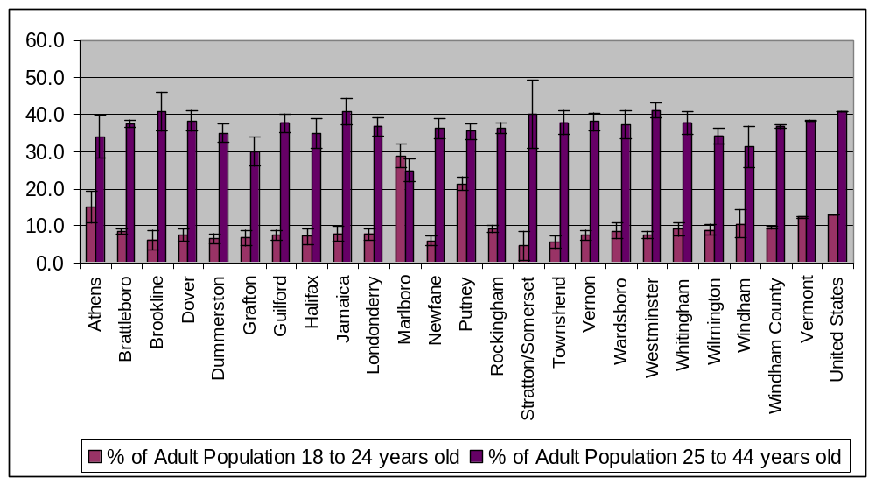
Source: U.S. Census Bureau, 2000

In reference to Figure 4, individuals age 45 to 64 represent 35.6% of Windham County adult population, more than that of Vermont (32.7%) and the United States (29.6%). Additionally, individuals age 65 and over constitute 18.3% of the Windham County adult population, compared with 16.8% statewide and 16.7% nationally. As the 45 to 64 year old population ages, this cohort will have a significant impact on the increase in the proportion of elders living in Windham County.

Figure 4: Percentage of Adult Population 45 to 64 Years Old and 65 and Older in Windham County, 2000
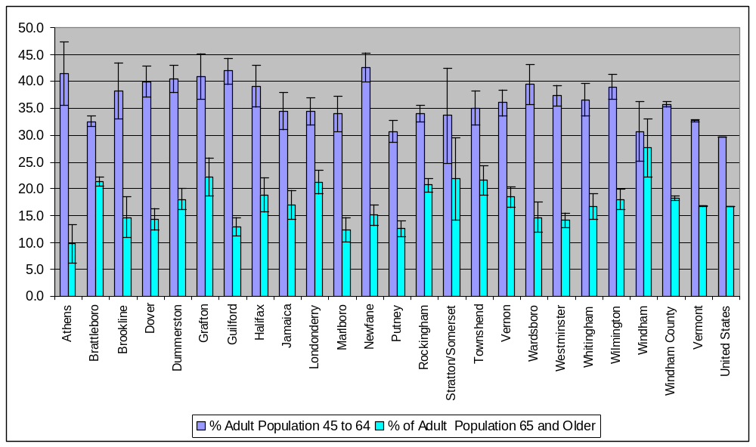
Source: U.S. Census Bureau, 2000

The working age population (20 to 64 year olds) in Windham County is expected to decrease slightly. In reference to Table 2, the portion of the Windham County population age 20 to 64 years old is projected to increase 2.2% between 2005 and 2010 and decrease by 2.4% between 2010 and 2015. This varies from the projections for the same population in Vermont and the United States. In Vermont, the 20 to 64 year old population is expected to increase by 4.7% between 2005 and 2010, with a slight increase of 0.9% between 2010 and 2015. In the United States, the 20 to 64 year old population is expected to increase by 4.9% between 2005 and 2010 and 2.6% for the period from 2010 to 2015.

Table 2: Population Projections, Age 20 to 64 Years Old, 2005 to 2015
Year | Windham County | % Change in Previous 5 Years | Vermont | % Change in Previous 5 Years | United States | % Change in Previous 5 years
2005 | 27,534 |  | 389,151 |  | 176,839,447
2010 | 28,140 | 2.2% | 407,307 | 4.7% | 185,456,094 | 4.9%
2015 | 27,463 | -2.4% | 411,134 | 0.9% | 190,367,063 | 2.6%
Source: U.S. Census Bureau, 2000

Between 1990 and 2000, the State saw an 8.9% increase in the number of residents aged 65 to 74 and a 19.6% increase in residents between the ages of 75 and 84. Windham County experienced a similar increase in residents aged 65 to 74 of 8.5% and a 16.0% increase for residents between the ages of 75 and 84. In the U.S., the number of residents aged 65 to 74 increased by 1.5% and the number of residents between the ages of 75 and 84 increased by 16.0%.

As highlighted in Table 3, the number of seniors in Windham County (age 65 and older) is projected to grow significantly by 15.3% from 2005 to 2010 and 24.1% from 2010 to 2015. These percentages are slightly higher than the statewide projections of 13.6% and 21.6%, respectively for the same time period. Population projections for this age cohort in the U.S. are expected to grow by 9.7% between 2005 to 2010 and by 16.3% between 2010 and 2015.

Table 3: Population Projections, Age 65 and older, 2005 to 2015
Year | Windham County | % Change in Previous 5 Years | Vermont | % Change in Previous 5 Years | United States | % Change in Previous 5 years
2005 | 6,578 |  | 82,398 |  | 36,695,904
2010 | 7,588 | 15.3% | 93,639 | 13.6% | 40,243,713 | 9.7%
2015 | 9,419 | 24.1% | 113,898 | 21.6% | 46,790,727 | 16.3%
Source: U.S. Census Bureau, 2005

As depicted in Figure 5, Windham County has a higher proportion of residents aged 85 and older than both Vermont and the United States. In 2000, these eldest residents comprised 2.0% of the population in Windham County compared to 1.6% in Vermont and 1.5% in the United States. However, Windham County, Vermont, and the United States all experienced increases in this population segment, though the rate of growth observed in Windham County, was slower than that of Vermont or the United States.

Figure 5: Percent of Population, Age 85 and Older, 1990 & 2000
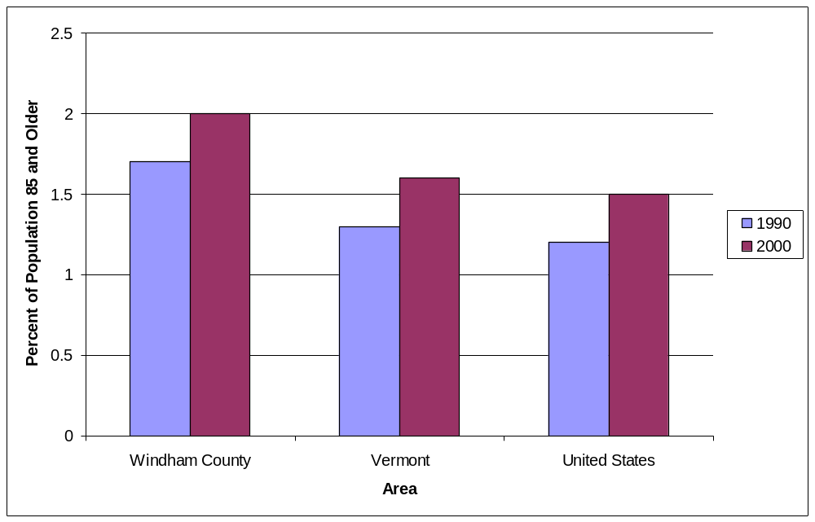
Source: U.S. Census Bureau, 2000

This subset of Windham County’s elderly residents is projected to continue to increase, though the rate of growth in this group appears to be slightly slowing down. Referring to Table 4, the number of Windham County residents, age 85 and older, is expected to increase 10.2% from 2005 to 2010 and 8.8% from 2010 to 2015. Though this increase is significant, it is slightly less than the projected statewide increases of 13.6% and 10.7%, respectively, for these same time periods and lower than the projected increases of 19.6% and 11.4% for the United States.

Table 4: Population Projections, Age 85 and older, 2005-2015
Year | Windham County | % Increase in Previous 5 years | Vermont | % Increase in Previous 5 years | United States | % Increase in Previous 5 years
2005 | 932 |  | 11,272 |  | 5,120,394
2010 | 1,027 | 10.2% | 12,807 | 13.6% | 6,123,458 | 19.6%
2015 | 1,117 | 8.8% | 14,173 | 10.7% | 6,821,666 | 11.4%
Source: U.S. Census Bureau, 2005

In 2005, older women outnumbered older men in Vermont. As seen in Table 5, the gender breakdown of residents aged 65 and older is 57.6% female versus 42.4% male, figures that are almost identical to those observed nationwide according to the 2005 American Community Survey. In 2005, among the 85 and older population, males comprised only 30.0% of the population and females 70.0%. The ratio is expected to shift in this group, as the life expectancy of men increases and the number of males ages 85 and older grows. By 2015, it is projected that the gender distribution in this age group (85 and older) will be 68.0% female and 32.0% male. Similar projections are unavailable at the local level for Windham County.

Table 5: Population Projections for Vermont Seniors by Gender, 2005-2015
Year | 2005 | % | 2015 | % | % Increase Over 10 Years
Aged 65+  Male  Female | 34,867  47,041 | 42.4%  57.6% | 50,583  62,904 | 44.6%  55.4% | 45.1%  32.8%
Aged 85+  Male  Female | 3,553  8,286 | 30.0%  70.0% | 5,097  10,832 | 32.0%  68.0% | 43.4%  30.7%
Source: U. S. Census Bureau, 2005

The rise in the number of residents aged 65 and older in Vermont is expected to occur at rate higher than that of other states. In reference to Table 6 the percentage of the State’s population age 65 and older is expected to almost double from 12.7% in 2000 to 24.4% in 2030. While Vermont ranked 26th in the nation in the largest population percentage of seniors in 2000, it is projected to rank 8th by 2030.

Table 6: Ranking of Vermont among the 50 States, Projected Population Age 65 and Older
Year | % Population ≥65 Years | Rank among 50 states
2000 | 12.7% | 26
2010 | 14.3% | 11
2030 | 24.4% | 8
Source: U.S. Census Bureau, 2005

Households

The way people are organized into households can provide insight into community needs and help local governments, elder services, and other institutions anticipate demand for services. All residents live in either group quarters or a household. Examples of group quarters include institutional settings such as correctional facilities, nursing homes and mental hospitals or non-institutional settings such as military barracks, group homes, college dormitories, missions and shelters. According to the U.S. Census Bureau, a household is synonymous with a housing unit, and the number of households is equal to the number of occupied housing units. Households are classified into two broad categories: a) family households consisting of related persons – married couples, couples with children, and siblings living together in a housing unit, and b) non-family households consisting of either persons living alone or unrelated persons sharing a housing unit. This data gives planners additional information on individual needs and the delivery of services.
As illustrated in Table 7, there were 18,375 households in Windham County in 2000. The number of households has been steadily increasing and has more than doubled over the past 50 years. However, the number of households statewide has grown at a slightly quicker rate compared to Windham County. As a result, the proportion of Vermont households located in Windham County has slowly but consistently decreased from 8.1% in 1950 to 7.6% in 2000.
Table 7: Windham County Households, 1950 to 2000
Year | Windham County | Vermont | Percent of VT households located in Windham County
1950 | 8,425 | 103,538 | 8.1%
1960 | 8,959 | 110,754 | 8.1%
1970 | 10,464 | 132,041 | 7.9%
1980 | 13,918 | 178,394 | 7.8%
1990 | 16,264 | 210,650 | 7.7%
2000 | 18,375 | 240,634 | 7.6%
Source: U.S. Census Bureau, 2000
Household composition in Windham County is fairly similar to that of Vermont statewide. In reference to Table 8, in 2000, family households were the majority at 62.4% of total households in Windham County and 63.0% of households in Vermont. In 2000, in both Windham County and Vermont, most family households consisted of married couples (49.2% in Windham County and 48.5% in Vermont), and the majority of non-family households consisted of a single person living alone (29.7% in Windham County and 27.8% in Vermont). In 2000, in Windham County, average household size was 2.4 individuals and average family size was 2.9 individuals. The averages for Vermont in 2000, were marginally higher, with an average household size at 2.4 individuals and an average family size at 3.0 individuals.

Table 8: Family and Household Characteristics
 | Windham County |  | Vermont
 | Count | % | Count | %
Total Households | 18,375 | 100% | 248,825 | 100%
Family households – total (families) | 11,456 | 62.4% | 156,832 | 63.0%
Married couple family | 9,039 | 49.2% | 120,684 | 48.5%
Female householder, no spouse | 1,770 | 9.6% | 24,632 | 9.9%
Male householder, no spouse | 647 | 3.5% | 11,516 | 4.6%
Non-family households – total | 6,919 | 37.7% | 91,993 | 37.0%
Householder living alone | 5,463 | 29.7% | 69,050 | 27.8%
2+ persons | 1,456 | 7.9% | 22,943 | 9.2%
Average household size | 2.4 | - | 2.4 | -
Average family size | 2.9 | - | 3.0 | -
Source: U.S. Census Bureau, 2000
Household composition in Windham County changed significantly from 1990 to 2000. As illustrated in Table 9, the number of family households in Windham County increased 5.4% during this period, while non-family households increased 28.2%. The single largest change in the non-family household category was a 30.7% increase in a householder living alone. During this same period, there were modest decreases in average household size (-5.6%) and average family size (-3.6%).

Table 9: Changes in Windham County Household and Family Characteristics
 | 1990 |  | 2000 |  | Change
 | Count | % | Count | % | Count | %
Total Households | 16,264 | - | 18,375 | - | 2111 | 13.0%
Family households – total (families) | 10,867 | 66.8% | 11,456 | 62.4% | 589 | 5.4%
Married couple family | 8,783 | 54.0% | 9,039 | 49.2% | 256 | 2. 9%
Female householder, no spouse | 1,574 | 9.7% | 1,770 | 9.6% | 196 | 1.2%
Male householder, no spouse | 510 | 3.1% | 647 | 3.5%
Non-family households – total | 5,397 | 33.1% | 6,919 | 37.7% | 1522 | 28.2%
Householder living alone | 4,180 | 25.7% | 5,463 | 29.7% | 1283 | 30.7%
2+ persons | 1,217 | 7.5% | 1,456 | 7.9% | 239 | 19.6%
Average household size | 2.5 | - | 2.4 | - | -.14 | -5.6%
Average family size | 3.0 | - | 2.9 | - | -.11 | -3.6%
Source: U.S. Census Bureau, 1990, 2000
Figure 6 depicts the Windham County total population living in group quarters from 1960 to 2000. In 2000, 1,126 Windham County residents lived in group quarters. Though this number has been significantly higher in the past, peaking at 1,885 individuals in 1970, in the last 25 years this figure has remained relatively stable.

Figure 6: Windham County Total Population Living in Group Quarters, 1960 to 2000
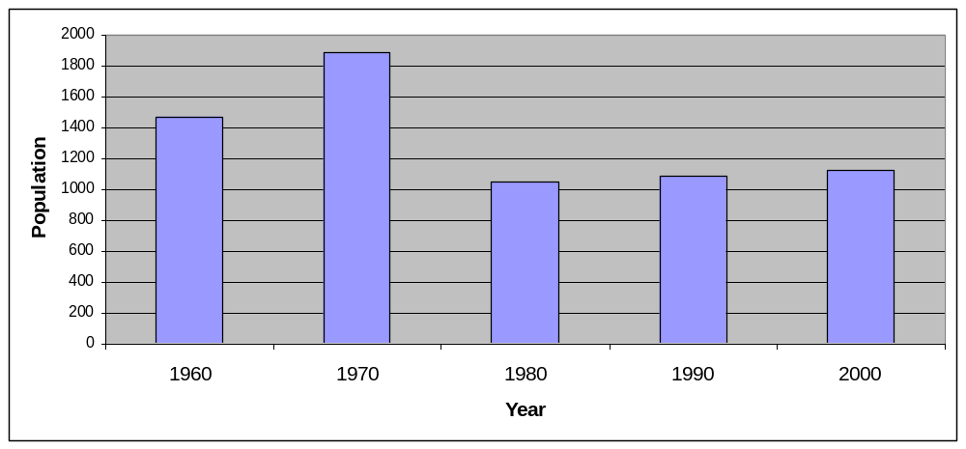
Source: U.S. Census Bureau, 2000
In 2000, there were 378 institutionalized persons (persons under formally authorized, supervised care, or custody) in Windham County, as described in Table 10. The institutionalized population of Windham County in 2000 was comprised entirely of nursing home residents. In 2000, the overall institutionalized population and the subset of institutionalized persons in nursing homes was at its lowest point in 20 years in both Windham County and Vermont.

Table 10: Institutionalized Population, 1980-2000
Year | Windham County | Windham County Institutionalized Population in Nursing Homes | Vermont | Vermont Institutionalized Population in Nursing Homes
1980 | 487 | 431 | 5,487 | 4,354
1990 | 519 | 483 | 6,161 | 4,809
2000 | 378 | 378 | 5,663 | 4,037
Source: U.S. Census Bureau, 1990, 2000
In 2000, households with individuals age 65 and older, accounted for 23.3% of the households in Windham County (Table11). This percent is about the same for Vermont at 22.5% and the U.S. at 23.4%. In terms of the composition of these households, in Windham County and Vermont, elders aged 65 and older were more likely to reside alone (43.6% in Windham County, 42.4% in Vermont) than elders nationwide (39.4%).

Table 11: Households, Age 65 and Older, 2000
Household type | Windham County |  | Vermont |  | USA
 | Count | Percent | Count | Percent | Count | Percent
Total Households | 18,375 | 100% | 240,634 | 100% | 105,480,101 | 100%
Households w/members aged 65 + | 4,284 | 23.3% | 54,149 | 22.5% | 24,672,708 | 23.4%
2+ person | 2,415 | 56.4% | 31,194 | 57.6% | 14,949,851 | 60.6%
Householder living alone | 1,869 | 43.6% | 22,955 | 42.4% | 9,722,857 | 39.4%
Source: U.S. Census Bureau, 2000
Current population trends are of great interest to those planning for the future. Referring back to Table 6, Windham County will have a significant percentage of residents who are age 65 and older. By 2030, this percentage of elders 65 and older is expected to increase dramatically. If current trends in the composition of households continue, the numbers of elders living alone will increase and there will be an even greater need for a wide variety of services to support this aging population and their caregivers.

Racial/Ethnic Distribution
Table 12 documents the racial/ethnic breakdown of Windham County residents. In 2000, residents of Windham County were primarily Caucasian (97.0%). Though the number of Windham County residents from other racial and ethnic groups, including African Americans, American Indians, Alaskan Natives, Asians, Pacific Islanders, Hispanics/Latinos, and individuals of other (undefined races) grew at rates ranging from 31% to 64% from 1990-2000, they still comprised less than 3% of the total population. These racial/ethnic distributions and trends reflect those documented in Vermont.

Table 12: Population by Race and Ethnicity, Changes from 1990 to 2000
 | Windham County 1990 | Windham County 2000 | % Change in Windham County | Vermont 1990 | Vermont  2000 | % Change in Vermont
Total | 41891 | 44082 |  | 566419 | 606855
Caucasian | 41,012  (97.9%) | 42,764  (97.0%) | +4% | 555,088  (98.0%) | 589,208  (97.1%) | +6%
African American | 157  (.4%) | 223  (.5%) | +42% | 1,951  (.3%) | 3,063  (.5%) | +57%
American Indian or Alaska Native | 74  (.2%) | 97  (.2%) | +31% | 1,696  (.3%) | 2,420  (.4%) | +43%
Asian / Pacific Islander | 259  (.6%) | 364  (.8%) | +41% | 3,215  (.6%) | 5,217  (.9%) | +62%
Hispanic / Latino (of any race | 303  (.7%) | 493  (1.1%) | +63% | 3,661  (.7%) | 5,504  (.9%) | +50%
Other race | 86  (.2%) | 141  (.3%) | +64% | 808  (.1%) | 1,443  (.2%) | +79%
Sources: U.S. Census, 1990, 2000

Land Development Patterns
Through the early 1950’s, the majority of Windham County area residents lived along public transit lines or within walking distance of necessary services or social contacts. Historically, people lived in villages or had ready access to public transit. Beginning in the 1950s, as the road system expanded to include highways and people had more access to private cars, communities expanded and most new development was outside of the concentrated village and town areas. This is evident in Figure 7, for the Town of Putney. Buildings existing in 1962 are shown as black dots and are concentrated around the center of Putney. New buildings between 1962 and 1977 marked in red are concentrated along Route 5 and Interstate 91. Buildings added between 1977 and 2002 are purple. This change in development patterns spread the housing away from public transit and reduced the proximity of households to services. This development pattern is similar to that of many other towns in the area.

Figure 7: Existing Buildings in Putney, Vermont, 2002
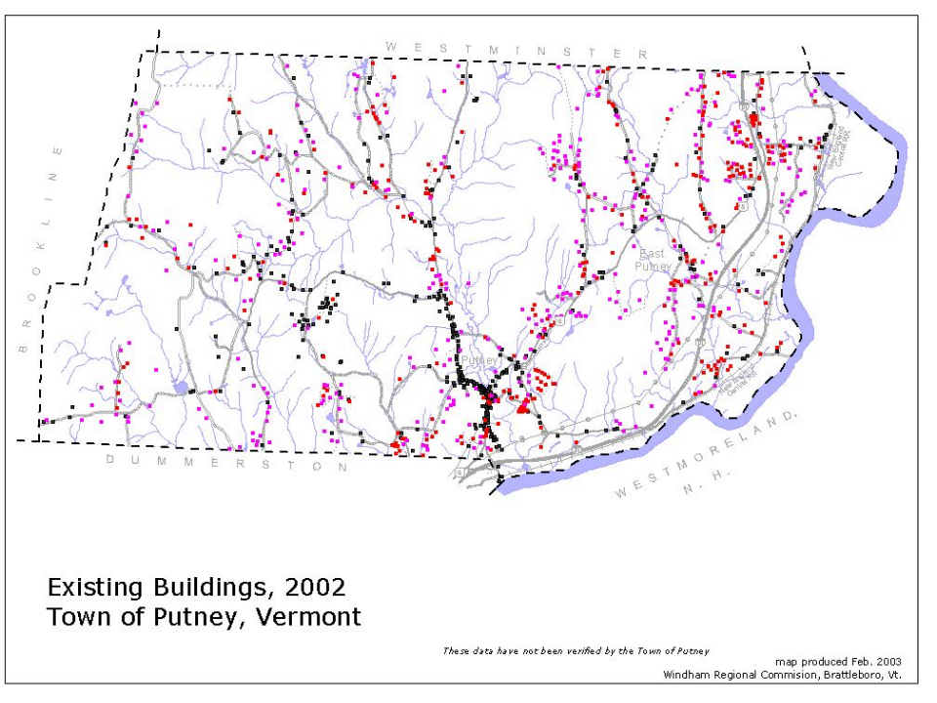

Social Environment
For the purpose of this report, the social environment refers to the general interaction among residents and their opportunities for civic, recreational, religious, social, and retail activities.
An important theme that emerged from focus groups was that Windham residents felt a strong sense of community. Participants frequently commented on the sense that their neighbors are their friends and they are concerned about what happens in their communities.
For survey respondents, these opportunities to participate in community-related activities are extremely important, and they would like to see them expanded. Table 13 outlines the social environment priorities among survey respondents. Over 70% of survey respondents report that increasing civic and volunteer opportunities for seniors has a high /medium priority. Over two thirds of survey respondents reported that increasing opportunities for indoor recreation and socializing with other adults has a high/medium priority. Almost two thirds of survey respondents reported that increasing opportunities for intergenerational activities, outdoor recreation and entertainment has a high/medium priority.

Over half of survey respondents reported that improving access to food stores (69.5%), clothing and retail store (65.2%), internet and e-mail (56.8%) and places of worship (50.2%) has a high/medium priority.

Table 13: Priorities for Development of the Social Environment among Survey Respondents
 | Priority Level
Developing more opportunities for… | High | Medium | Low | Don’t Know
Socializing with other adults | 29.9% | 37.6% | 23.1% | 9.4%
Civic involvement | 29.2% | 43.2% | 16.9% | 10.6%
Volunteering | 28.4% | 44.0% | 19.4% | 8.2%
Indoor recreation | 26.2% | 42.9% | 22.7% | 8.2%
Intergenerational activities | 25.8% | 39.5% | 24.0% | 10.7%
Outdoor recreation | 20.1% | 44.9% | 29.1% | 6.0%
Entertainment | 19.0% | 36.2% | 37.1% | 7.8%
Improving Access to…
Food stores | 42.2% | 27.3% | 23.2% | 6.9%
Clothing and retail stores | 32.4% | 32.8% | 28.6% | 6.2%
Internet and email | 22.2% | 34.6% | 29.9% | 13.2%
Places of worship | 17.7% | 32.5% | 38.1% | 11.7%

Vermont residents are extremely active on a civic level. According to the New York Public Interest Research Group, in 2004, 62.3% of Vermont residents voted compared to 52.3% of the U.S. population. Over 60% of survey respondents reported volunteering in the past year, for an average of 13.4 hours per month. Vermont also has one of the nation’s highest rates of volunteerism at 39.8%, though focus group participants indicated that they would like to see even more residents volunteer in the community.

Focus group participants feel that the Windham County area lacks sufficient intergenerational opportunities for seniors. Increasing opportunities for seniors to interact with others, across the lifespan, is important to focus group participants as well as, survey respondents. Focus group participants indicated a need for increased indoor and outdoor recreational activities. Specific indoor recreation activities identified by focus groups participants as appealing include senior-friendly resources like pools, walking tracks, and group fitness programs. Focus group participants also emphasized their interest in recreational activities such as hiking, camping, and hunting.

Focus group participants also noted a large number of local individual artists and the important role they play in the community both socially and economically. Focus group participants frequently noted the arts community as an asset to the area and indicated that they would like to see more arts activities developed in the area.

Focus group participants also reported that they would welcome an improvement in choices of retail outlets for the purchase of food and clothing. Focus group participants also shared that having increased access to Internet and email would be an additional opportunity to connect with others.

Despite the positive social environment of Windham County described by many focus group participants, some expressed a fear of isolation as they grow older. They discussed concerns of increasing struggles for aging individuals to get the services and support they might need and a lack of awareness among the general population of the aging process. They would like to see the “community of caring” that they have experienced in Windham County, develop a greater respect for aging individuals and a greater understanding of the aging process itself, and for seniors to be able to take a more active role in the community. In addition, some focus group participants, identified other characteristics that foster a sense of community, like in-town housing choices, access to services without depending on a personal automobile, and opportunities to socialize with friends and neighbors. One participant noted, “It is a lot easier to have a supportive community if you live in a village or neighborhood.”

Notwithstanding their concerns, the majority of survey respondents believe that Windham County is appealing to seniors. As shown in Table 14, 86.2% of respondents strongly agree or agree with the statement “Windham County is a good place to grow older”, whereas, only 7% of respondents disagree or strongly disagree with the statement.

Table 14: Agreement/Disagreement with Statement “Windham County is a good place to grow older” among Survey Respondents
Response | Percent
Strongly Agree | 29.9%
Agree | 56.3%
Disagree | 6.3%
Strongly Disagree | 0.7%
Don’t Know | 6.9%

ECONOMIC INDICATORS
This section of the report focuses on the economic indicators of employment, income, and housing.

Employment
As depicted in Table 15, in 2005, both Windham County and Vermont were experiencing similar and somewhat low rates of unemployment, at 3.4%, and 3.5%, respectively, compared to 5.1% for the U.S. In the first half of the decade, Windham County experienced a 0.4% increase in the rate of unemployment compared to a 0.6% increase in Vermont and a 1.1% increase in the U.S.

Table 15: Employment Characteristics and Trends, 2000 - 2005
 | Windham County | Vermont | United States
Unemployment Rate (percent)
2000 | 3.0% | 2.9% | 4.0
2005 | 3.4% | 3.5% | 5.1
% change in Unemployment rate  2000-2005 | +0.4% | +0.6% | +1.1%
Labor Force (count)
2000 | 22,600 | 331,550 | 142,500,000
2005 | 25,050 | 355,900 | 149,500,000
% Change in Labor Force  2000-2005 | +10.8 | +7.3% | +4.9%
Covered Employment (count)
2000 | 24,067 | 296,468 | 129,877,063
2005 | 22,978 | 298,491 | 131,571,623
% Change in Covered Employment 2000-2005 | -4.5% | +0.7% | +1.3%
Source: U.S. Census Bureau, Vermont Department of Labor, US Bureau of Labor Statistics 2006

The labor force is a measure of residents age 16 and older who are employed or are unemployed but looking for work. The estimate includes agricultural workers, unpaid family members, and the self-employed. In 2005, there were approximately 25,050 individuals in Windham County’s labor force compared to 331,550 individuals in Vermont’s labor force. Windham County saw an increase of 10.8% in its labor force from 2000 to 2005 compared to 7.3% in Vermont and 4.9% in the U.S.

Covered employment is a measure of residents employed in jobs that are governed by Vermont’s Unemployment Compensation law. Jobs that are “off the books” are not included, as well as those jobs where one is self-employed or works in an agricultural production firm. Covered employment in Windham County decreased 4.5% from 2000 to 2004 compared to a slight increase of 0.7% in Vermont.

In 1999, the median earnings for individuals 16 years and older in Windham County was $20,960 and $21,497 for Vermont. Both areas had lower median earnings than the nation as a whole which was $23,755. With reference to Table 16, in Windham County, the median earning of individuals varied from a low of $11,875 for Marlboro to a high of $23,393 for Vernon.

Table 16: Median Earnings by Town, 1999
Town | Median Earnings
Vernon | $23,393
Dummerston | $22,882
Newfane | $22,872
Grafton | $22,419
Guildford | $22,340
Westminster | $22,135
Dover | $21,843
Townshend | $21,296
Brookline | $21,161
Brattleboro | $21,073
Rockingham | $20,850
Whitingham | $20,643
Stratton | $20,625
Wardsboro | $20,320
Londonderry | $20,112
Wilmington | $20,000
Athens | $19,605
Windham | $19,602
Jamaica | $19,514
Halifax | $18,594
Putney | $18,138
Marlboro | $11,875
Somerset | Undisclosed
Windham County | $20,960
Vermont | $21,497
United States | $23,755

Table 17 describes covered employment in Windham County by industry. In 2004, most (87.0%) of Windham County employment was through privately-owned industries compared to jobs in government (13.0%). Private-industry employment can be divided into service-providing employment and goods producing employment, with 70.2% of employment in service-providing employment and 16.8% of employment in goods producing jobs.

Table 17: Windham County Covered Employment by Industry in 2004
Industry | Count | Percent
Government Ownership | 2,992 | 13.0%
Private Ownership | 19,985 | 87.0%
Service Providing | 16,118 | 70.2%
Accommodation and food services | 3,275 | 14.3%
Retail trade | 2,809 | 12.2%
Health care and social assistance | 2,539 | 11.1%
Wholesale trade | 1,586 | 6.9%
Educational services | 1,469 | 6.4%
Other services, except public administration | 692 | 3.0%
Finance and insurance | 643 | 2.8%
Administrative and waste services | 685 | 3.0%
Information | 339 | 1.5%
Real estate | 289 | 1.3%
Arts, entertainment, and recreation | 162 | 0.7%
Professional, scientific, and technical services | D | D
Management of companies and enterprises | D | D
Transportation and warehousing | D | D
Utilities | D | D
Goods Producing | 3,867 | 16.8%
Manufacturing | 2,488 | 10.8%
Construction | 1,103 | 4.8%
Agriculture, forestry, fishing & hunting | D | D
Mining | D | D
Source: Vermont Department of Labor, 2005

Focus group participants indicated that they would like to continue working if they are healthy and, along with survey respondents, would like to see employment opportunities for seniors expanded in Windham County. Approximately 75% of survey respondents believe that expanding employment opportunities for the elderly to support successful aging is a high/medium priority.

As Vermont’s population ages and it’s working age population begins to decline, there will be an impact on the labor pool and ultimately the state’s economy.

Income and Poverty Status
This section describes the income and poverty trends within Windham County and in comparison to rates in Vermont and the United States. In reference to Table 18, Windham County’s median household income of $38,204 in 2000 was somewhat lower than the median household incomes in both Vermont ($40,856) and the U.S. ($41,994). Windham County’s per capita income (the sum of the total income of residents age 15 or older in a geographic area divided by the total population in that area) of $20,533 was relatively equivalent to that of Vermont ($20,625) and just slightly lower than the U.S. ($21,587).

Living in poverty is defined as having a total household income less than the poverty threshold specified for the applicable family size, age of householder, and number of related children under 18 present. In 1999, the poverty threshold in the U.S. for a family of four with two dependents under 18 years of age was $16,895. Based upon data from the 2000 Census, Windham County which had a rate of 6.1% of families living below the poverty level fared slightly better than the state (6.3%) and significantly better than the nation (9.2%).

The 1999 poverty threshold in the U.S. for an individual was $8,501. Based on 2000 U.S. Census data, 9.4% of individuals in both Windham County and Vermont were living below the poverty threshold compared to 12.4% of individuals nationwide.

Table 18: Selected Economic Indicators, 2000
 | Windham County | Vermont | National
Median¹ household income² (1999) | $38,204 | $40,856 | $41,994
Per capita income³ | $20,533 | $20,625 | $21,587
Percent of families below poverty level⁴ | 6.1% | 6.3% | 9.2%
Percent of individuals below poverty level⁴ | 9.4% | 9.4% | 12.4%
¹The median is the middle number in a given sequence of numbers; median household income would be the household income for which half of all household incomes fall above it and half of all household incomes fall below it
²Household income is the total sum of all money income received in calendar year by household members age 15 and older, whether related to head of household or not
³Per capita income is the mean income computed for every man, woman, and child in a particular group. It is derived by dividing the total income of a particular group by the total population in that group.
⁴Living in poverty is defined as having a total family income or unrelated individual income in the household less than the poverty threshold specified for the applicable family size, age of householder, and number of related children under 18 present; 1999 poverty threshold for family of 4: $16,895; 1999 threshold for individuals: $8,501
Source: US Census Bureau, 2000

Throughout Windham County, income can vary by town. Table 19 depicts the median adjusted income by town. In 2004, Vernon had the highest median adjusted income at $37,677, compared to Athens with a median adjusted income of $21,454.

Table 19: Median Adjusted Income by Town, 2004
Town | Median Adjusted Income
Vernon | $37,677
Dummerston | $33,632
Marlboro | $32,614
Brookline | $31,665
Guilford | $30,609
Grafton | $30,404
Newfane | $29,480
Halifax | $29,425
Westminster | $29,351
Whitingham | $29,103
Townshend | $26,893
Windham | $26,723
Stratton | $26,619
Putney | $25,852
Dover | $25,551
Brattleboro | $25,196
Jamaica | $24,778
Londonderry | $24,774
Rockingham | $24,198
Wilmington | $24,066
Wardsboro | $23,222
Athens | $21,454
Somerset | D
D= Data which cannot be disclosed.
Source: Vermont Department of Taxes, 2005

With reference to Table 20, the number of low-income households (below 80% of the area median income) with householders age 62 and older increased from 2000-2005 and is expected to continue to increase through 2010. The largest increase observed from 2000-2005, of 11.5%, was among the group with incomes <=30% of the area median. By 2010, this poorest segment of elderly households is expected to increase by 18.5%. Only one sub-segment of low-income households—elderly households with incomes 31% to 50% of the area median—experienced a decrease in numbers from 2000-2005 and is expected to remain stable through 2010. Overall, the number of low-income elderly households is expected to grow 9.1% over this decade, from 2,600 in 2000 to 2,836 in 2010.

Table 20: Estimated Number of Windham Households with Householders Age 62+ by Household Income Relative Estimated to Area Median, 2000-2010
Household Income relative to area median | 2000 | 2005 | 2010 | % change 2000-2005 | % change 2000-2010
<=30% | 805 | 897 | 953 | 11.5% | 18.5%
31 - 50% | 838 | 800 | 797 | -4.6% | -4.9%
51 - 60% | 338 | 345 | 383 | 2.1% | 13.4%
51 - 80% | 619 | 649 | 703 | 4.9% | 13.6%
>80% | 2,066 | 2,074 | 2,139 | 0.1% | 3.5%
Total Households | 4,666 | 4,766 | 4,975 | 2.2% | 6.6%
Total <=80% | 2,600 | 2,692 | 2,836 | 3.5% | 9.1%
Source: Vermont Department of Housing and Community Affairs, 2005
Original data source: U.S. Census Bureau, Claritas; Analysis of data: Gent Communications

In addition to income and wage data, use of food shelves and community kitchens is an indicator of the economic viability among community residents. In 2005, 2,148 Vermont households with elderly residents aged 65 and older used food shelves (take home groceries)—a 12% increase from 2003. In Windham County, these households accounted for 20.3% of the total food shelf caseload. In Windham County, 335 elderly households access emergency food shelves monthly and 532 meals are served each month to elderly patrons of community kitchens (Vermont Department for Children and Families, 2005). According to study participants, the food shelves and Meals on Wheels programs in Windham County are valuable assets to the community.

Survey respondents reported experiencing financial difficulties of various natures, as seen in Table 21. Among survey respondents the most common financial difficulties reported were paying for gasoline for a car and paying medical bills. About 10% of survey respondents reported having had problems paying for these items in the past year. Nearly as many (8.8%) reported having trouble paying for housing repairs in the past year. Paying for utilities and food had also been problematic in the past year for 7.6% and 6.1% of survey respondents, respectively. Paying for medications, clothing, transportation, housing, and health insurance were reported by about 5% of respondents. Approximately half (50.9%) of the survey respondents reported that in the past year they experienced no difficulties paying for any of the common household expenditures analyzed in this assessment.

Table 21: Financial Challenges among Survey Respondents
In the past year, experienced difficulty paying for… | Percent
Gasoline for car | 10.1%
Medical bills | 10.1%
Housing repairs | 8.8%
Utilities | 7.6%
Food | 6.1%
Medications | 5.5%
Clothing | 5.2%
Transportation | 4.9%
Housing | 4.9%
Health insurance | 4.9%

Respondents believe that aging in Windham County could be made easier if there was greater access to financial planning services for the elderly. At least one of every five respondents indicated that improving access to financial planning services should receive the highest priority in the Windham County area, while two in five feel it should be a medium priority.

Housing
Like many areas across the United States, Windham County and Vermont have experienced rapidly rising housing costs. Affordable, year-round housing in the area is in short supply.

Table 22 compares the median and average prices of a primary residence (as opposed to a second/vacation home) in Windham County and Vermont from 1995 to 2005. In the last 10 years, the median home price for a primary residence in Windham County increased 83.2%, from $98,250 to $180,000, and the average home price increased 89%, from $113,197 to $213,909. Statewide, the increases in home prices slightly outpaced those observed in Windham County. The median home price in Vermont increased 86.9%, from $99,000 to $185,000, while the average home price increased 92.8% from $114,460 to $220,671.

Table 22: Pricing Trends, Primary Residences, 1995-2005
 | 1995 | 2005 | % increase
Median Home Price
Windham County | $98,250 | $180,000 | 83.2%
Vermont | $99,000 | $185,000 | 86.9%
Average (Mean) Home Price
Windham County | $113,197 | $213,909 | 89.0%
Vermont | $114,460 | $220,671 | 92.8%
Source: Vermont Housing Finance Agency

In 2000, the housing occupancy rate in Windham County, was at 68.0%, which is significantly below the statewide average of 81.7% (see Table 23). The low housing rate in the area can be attributed to the fact that Windham County is a draw for weekend and seasonal visitors. Even though Windham County has a large cache of unoccupied housing units, the majority of these, 86.7%, are characterized as being for “seasonal, recreational, or occasional” use. These housing units are often not designed for year round use and are built and priced for the second home market. 27.8% of the housing units in Windham County are designated as being for “seasonal, recreational or occasional use,” compared to 14.6% of housing units in Vermont. The significantly low occupancy rate for Windham County is attributed the higher percentages of “seasonal, recreational, or occasional” housing units in various towns in the County. For example, 93.9% of the housing units in Stratton and Somerset are designated as “seasonal, recreational or occasional” and the housing occupancy rate there is only 5.5%. Of note, only seven towns in Windham County have occupancy rates higher than that of the state.

Table 23: Housing Occupancy Rates, 2000
Town/Area | Housing Occupancy Rate | Percentage of Housing Units Designated for “Seasonal, Recreational or Occasional Use”
Athens | 67.6 | 19.0%
Brattleboro | 94.3 | 1.3%
Brookline | 67.9 | 27.7%
Dover | 22.2 | 74.4%
Dummerston | 89.1 | 8.2%
Grafton | 67.1 | 24.4%
Guilford | 87.1 | 6.7%
Halifax | 63.3 | 32.5%
Jamaica | 43.0 | 52.4%
Londonderry | 55.4 | 39.0%
Marlboro | 66.4 | 30.8%
Newfane | 70.9 | 26.1%
Putney | 91.3 | 4.9%
Rockingham | 90.8 | 3.5%
Stratton/Somerset | 5.5 | 93.9%
Townshend | 70.2 | 23.8%
Vernon | 94.5 | 2.0%
Wardsboro | 46.7 | 49.6%
Westminster | 88.2 | 7.6%
Whitingham | 64.2 | 32.3%
Wilmington | 44.4 | 52.3%
Windham | 42.4 | 51.4%
Windham County | 68.0 | 27.8%
Vermont | 81.7 | 14.6%
Source: U.S. Census Bureau, 2000

Table 24 demonstrates that Windham County’s housing stock is relatively old. Over 40% of all units were built before 1959, making them over 45 years old, and over half were built before 1970. Only 5.1% of all housing units have been constructed since 1995.

Table 24: Age of Housing Stock in Windham County
Year Built | Total  (count) | Percent of total
1999-March 2000 | 493 | 1.8%
1995-1998 | 883 | 3.3%
1990-1994 | 1,453 | 5.4%
1980-1989 | 5,998 | 22.2%
1970-1979 | 4,309 | 15.9%
1960-1969 | 2,951 | 10.9%
1940-1959 | 2,734 | 10.1%
1939 or earlier | 8,218 | 30.4%
Source: U.S. Census Bureau, 2000

Housing Costs
The increase in housing costs has led to a gap between residents’ income and their ability to find affordable housing. Table 25, from the State of Vermont’s 2005 Windham County Housing Needs Assessment, compares the cost of purchasing a new home with the median income level in the county. In 2005, there was an estimated $53,646 gap between the median home price and the price of a home that would be considered affordable (defined as spending 30% of income on housing expenses) to a resident earning the median income. Households earning the median income would need to earn approximately $19,473, or 44%, more than they are currently making in order to be able to afford a median-priced home. Placed in the context of trends five years earlier in 2000 and projected trends for 2010, the gap in housing affordability is rapidly increasing as home prices rise and interest rates increase. It is estimated that by 2010, those earning the median income in Windham County would almost need to double their income in order to be able to afford to purchase a home at the median price in the county.

Table 25: Comparison of “Affordable” Home Prices and Income
 | Median Income | Median home price | Affordable home based on median income | Income needed to afford median home | Gap between “affordable” home and median home price | Gap between income needed to afford home & median income
2000 | $38,553 | $112,750 | $95,412 | $50,628 | $17,338 | $12,075
2005 | $43,822 | $170,995 | $117,348 | $63,295 | $53,646 | $19,473
2010 | $48,894 | $203,373 | $96,338 | $93,218 | $107,035 | $44,324
Note: Interest rates: 2000 annual average (8.05%); 2005 projected (5.68%); 2010 10-year average (8.52%)
Source: Vermont Department of Housing and Community Affairs
Original data sources: Freddie Mac weekly survey (interest rates); Claritas (median income); VT Property Transfer Tax data (home prices)

The gap in affordable housing affects Windham County residents of all ages. As illustrated in Figure 8, there are many more low-income renters in Windham County than there are affordable housing units. For example, in 2005, there were 3,791 low-income households and a total of 958 subsidized housing units for rent in Windham County. Among the 2,946 low-income non-elderly households there were only 518 subsidized housing units available with no age restrictions. Among the 845 low-income elderly households there were only 440 subsidized housing units set aside with age and/or disability restrictions. While the other 518 subsidized units for rent were available to the low-income elderly households, they were competing with the large number of low-income households.

Figure 8: Comparison of Low Income Renters and Subsidized Units, Windham County, 2005
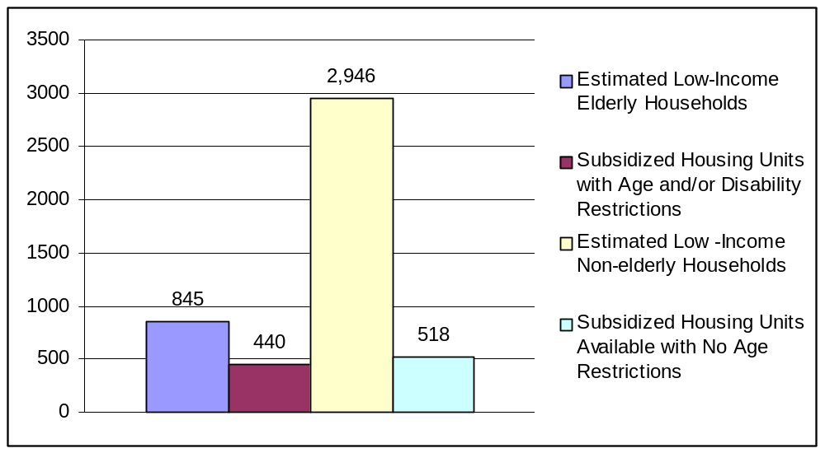

Source: Gent Communications analysis of Claritas income data and Vermont Affordable Rental Housing Directory, 2005

Assessment participants are well aware of the housing trends in their area. A major theme identified in focus groups was the lack of affordable housing, particularly for those who wish to enter assisted living or downsize from their current accommodations. As seen in Table 26, while most survey respondents indicated that their current residences are adequate for their needs (95.5%) and are affordable (94.1%), almost one-third (29.1%) of survey respondents expressed concern about their living accommodations in the next five years.

Table 26: Housing Experiences among Survey Respondents
Indicator | Percent
Living accommodations are adequate for needs | 95.5%
Living accommodations are affordable | 94.1%
Have concerns about living accommodations w/in next 5 years | 29.1%

Concerns among survey respondents stem from fears that they may not be able to maintain their properties as they age—a concern that was also echoed by focus group participants—as well as their concern over higher taxes, utilities, and general living expenses. These issues are nearly identical to those shared by the small minority of residents that reported their current accommodations are not appropriate or affordable.

Despite these apprehensions and the data on the lack of affordable housing in the area, most survey respondents indicated that in the next five years they were not likely to move within Windham County, to another county in Vermont or out of state. In Table 27, only 20.1% of survey respondents indicated that it is at least somewhat likely to very likely they will move to another residence within Windham County in the next five years, and only 8% indicated that it was at least somewhat likely to very likely that they would move to another county in Vermont during that period. Only 9% of survey respondents felt that it was at least somewhat likely to very likely that they will move out of Vermont altogether in the next five years. Survey respondents and focus group/interview participants indicated that the weather and family ties elsewhere were influencing their decision to move from Vermont.

Table 27: Likelihood of Changing Residence in Next 5 Years (%) among Survey Respondents
 | Very likely | Likely | Somewhat likely | Not likely | Don’t know
What is the likelihood that you will move within Windham County in the next 5 years? | 4.2% | 5.8% | 10.1% | 59.4% | 20.5%
What is the likelihood you will move from Windham County but stay in Vermont in the next 5 years? | 2.6% | 0.6% | 4.8% | 78.5% | 13.5%
What is the likelihood that you will move from Vermont in the next 5 years? | 1.7% | 2.0% | 5.3% | 74.1% | 16.9%

In Table 28, almost three-quarters (72.7%) of the survey respondents feel that increasing the availability of quality, affordable rental housing deserves the highest priority. In addition, over half of the survey respondents indicated that increasing the availability of affordable housing for purchase and increasing the availability of services to help older individuals care for their homes should receive the highest priority (57.4% and 59.8%, respectively).
Table 28: Housing Priorities among Survey Respondents
 | Priority Level
Housing Issues | High | Medium | Low | Don’t know
Increasing quality, affordable housing for purchase | 57.4% | 18.9% | 17.2% | 6.6%
Increasing quality, affordable rental housing | 72.7% | 14.8% | 7.4% | 5.1%
Increasing services to help older individuals take care of their homes? | 59.8% | 29.7% | 5.1% | 4.3%

TRANSPORTATION
With the rural nature of the Windham County area and Vermont as a whole, access to adequate transportation is vital for residents to get through their daily lives. As discussed in the Community Profile section, land development patterns have spread the resident population outside of a concentrated village center. As noted in Table 29, survey respondents rely heavily on cars to get to and from places. Seventy percent of the respondents currently drive. Of those who drive, just under ten percent (9.5%) drive only in the day light. Just over 10% of survey respondents have stopped driving, with an approximately equal amount (9.8%) who never drove.

Table 29: Driving Status of Survey Respondents
Use of a vehicle for personal needs
Drives in daylight and at night | 70.2%
Drives in daylight only | 9.5%
Has stopped driving | 10.5%
Never drove | 9.8%

Table 30, lists the variety of modes of transportation survey respondents regularly rely on for getting from place to place. Almost three-quarters of survey respondents (72%) regularly rely on their own vehicle, while 20.5% regularly walk, 13.4% regularly rely on a friend/neighbor to drive, and 10.7% regularly use public transportation to get from place to place.

Table 30: Types of Transportation Regularly Relied on by Survey Respondents
Type of Transportation
Own Vehicle | 72.0%
Walking | 20.5%
Friend/Neighbor Drives | 13.4%
Public Transportation | 10.7%
Bus/Van Service Provided by Housing Provider | 7.3%
Bicycle | 7.2%
Family Member Drives | 5.2%
Taxi Cab | 4.9%
Volunteer Drives | 2.7%
Other | 3.0%

Transportation is a critical issue for residents of the Windham County area. Over half (53.8%) of survey respondents feel that improved transportation should be given the highest priority when considering factors that would support successful aging in the county, while an additional 29% believe it is at least a medium priority. Transportation proves to be a challenge for the large majority of survey respondents. Eighty-eight percent reported that they experience challenges getting to the places that they need to go to because of barriers such as limited hours for public transportation, high gas prices, poor weather, the physical difficulties associated with walking, getting into cars and buses, climbing stairs, and uneasiness of being dependent upon others for rides.

Commuting
According to the 2000 Census, Windham County residents who work enjoy a slightly quicker commute to work than their statewide and nationwide counterparts (see Table 31). The average commute time in Windham County is 20 minutes compared to 22 minutes in Vermont and 26 minutes nationally.

Table 31: Commuting to Work
 | Windham County | Vermont | United States
Average commute time (minutes) | 20 | 22 | 26
Means of transportation (%)
Drive | 85.4% | 87.1% | 88.0%
Walk | 6.1% | 5.6% | 2.9%
Public transportation | 0.7% | 0.7% | 4.7%
No commute/Work at home | 6.8% | 5.7% | 3.3%
Source: U.S. Census Bureau, 2000

Table 31 also documents Windham County residents’ means of transportation to work. The majority of residents (85.4%) drive to work, whereas, 6.8% of Windham County residents work from home. Additionally, 6.1% of Windham County residents walk to work. Of this population, 38.7% live in Brattleboro and an additional 17.9% live in Rockingham. Less than 1% use public transportation to get to work. While public transportation is not available in all Windham County towns, of the commuters using public transportation, 29.8% live in Brattleboro and 11.8% live in Wilmington.

These overall rates are similar to those seen in Vermont, though somewhat different than national rates. Windham County residents, like residents of Vermont, are less likely than individuals throughout the United States to take public transportation, while they are more likely to walk to work or work from home.

Public Transportation
Though participants of the community assessment believed that public transportation options could be improved, many reported making use of the three bus lines that provide fixed-route services in the area. The BeeLine serves the town of Brattleboro; hours are limited to Monday-Saturday 6:30 am – 7:20 pm and Sunday 9 am – 3:30 pm, and the adult fare is $0.75. There are discounts for children and students but not seniors. Connecticut River Transit (CRT), based in Springfield, VT, offers in-town bus service in a number of the communities with higher population densities. Commuter buses and between-town buses serve a variety of routes. Buses are allowed to pick up and drop off passengers anywhere along their routes. Though there is a suggested fare for each route, no one is refused service due to inability to pay. Lastly, the Deerfield Valley Transit Association (DVTA), based in West Dover, runs the MOOver, which is a free, year-round, deviated fixed route and commuter bus service that serves almost 200,000 riders annually.

In addition to these fixed-route public bus services, transportation is available on a need-based demand basis through Vermont’s Elderly and Disabled Program. This program funds CRT and DVTA to provide transportation to critical medical services, adult day programs, meal sites, and retail outlets.

However, the Windham Regional Commission noted that these services do not meet current needs. Both CRT and DVTA are experiencing an increase in ridership on their fixed routes, and are considering expanding services both in terms of more trips and additional routes. Funding, however, continues to be an issue. Current state funding levels are not adequate to maintain the present level of fixed rate services into the future.

Another aspect of public transportation, need-based on-demand services –particularly for critical medical services – has been limited due to funding constraints. The Elderly and Disabled Program capped the number of trips allowable per week for certain services. Most notable are the caps imposed for transportation to kidney dialyses, which, at the time of this report, has been limited to two trips per week, even though patients typically have treatment three times per week. Similar limits have been put on transportation to services for cancer treatment. The restriction of services is likely to continue, as funding to CRT and DVTA for the provision of these services actually decreased slightly from 2006 to 2007. Study participants noted that volunteer based services by community Cares groups have been essential in making up the shortfall.

As the percentage of elderly in Windham County continues to increase over the coming years, there will be a greater need for public transportation services in the area. Currently, federal funding accounts for half of the Vermont Agency of Transportation’s annual budget. Though the Agency was able to increase funding for infrastructure development and services in 2007, this funding stream expires in three years in FY2009. Study participants noted that, in the long term, there are limited prospects for increased federal funding. According the U.S. General Accounting Office, with the first wave of the baby boomer generation being eligible for early retirement starting in 2008, federal funding will increasingly need to be allocated to support the entitlement programs of Social Security and, most substantially, Medicare.

Planners, participating in the study, noted that if the need for public transportation for the elderly is to be met, it will require improving the efficiencies of providing services. The current Agency of Transportation Plan has already identified Transit Oriented Development as an important piece of this effort.

Walking
As noted in Table 30, 20.5% of survey respondents regularly walk to get to their destination. Focus group participants expressed concern over the conditions of the sidewalks in the region. As part of their “vision” for a senior-friendly Windham County would be like, some respondents indicated that creating smooth, wide sidewalks would be helpful in supporting successful aging in the area. Current state funding for walking facilities is limited. It is unclear whether the Vermont Agency of Transportation’s future expenditures for the improvement of pedestrian facilities will continue at the same level as the last four years.

CRIME
Vermont has consistently been documented to have some of the lowest rates of crime in the country on a variety of indicators. While many important issues were examined in this assessment, study participants did not express any concerns about crime in the area.

Windham County is an extremely safe community in terms of violent crime (see Table 32). In 2004, violent crime rates in Windham County were 165 per 100,000 people compared to 112 per 100,000 people in Vermont. The Windham County violent crime rate is about one-third the rate of violent crime observed nationwide. However, while the rate of violent crime was fairly consistent in Vermont and decreased 8% nationwide during the first half of the decade, the violent crime rate in Windham County increased 21% from 2000 to 2004.

Table 32: Rates of Crime, 2000 2004
 | 2000 | 2004 | % change
Violent Crime (per 100,000 people)*
Windham County | 136 | 165 | +21%
Vermont | 114 | 112 | -2%
United States | 506 | 466 | -8%
Property Crime (per 100,000 people)*
Windham County | 3,361 | 2,331 | -31%
Vermont | 2,873 | 2,308 | -20%
United States | 3,618 | 3,517 | -3%
Elder Abuse (per 10,000 people)**
Windham County | 7.4 | 12.4 | 68%
Vermont | 14.1 | 13.7 | -3%
*Source: United States Department of Justice
**Source: Vermont Department of Disabilities, Aging and Independent Living

In Table 32, the level of property crime (burglary, larceny-theft, and motor vehicle theft) in Windham County in 2004 was similar to that observed in Vermont (2,331 per 100,000 people vs. 2,308 per 100,000 people). In comparison, both Windham County and Vermont experienced considerably less property crime than the nation (3,517 per 100,000 people). Windham County saw a drop of 31% in the amount of property crime during the first half of the decade compared to a 20% decrease in Vermont and a 3% decrease in the U.S. from 2000 to 2004.

The final crime statistic documented in Table 32 is elder abuse. The level of elder abuse in Windham County increased 68% from 7.4 incidents per 10,000 people in 2000 to 12.4 per 10,000 people just four years later in 2004. Despite this increase, the rate of elder abuse in Windham County is 10% less than the statewide rate. It should be noted, however, that while Vermont law mandates reporting of abuse, neglect or exploitation of people age 60 years or older, data from the National Elder Abuse Incidence Study suggests that only about one-sixth of incidents are reported to authorities.

EDUCATION
This section of the report focuses on literacy, educational attainment, and opportunities for education and training.

Literacy
The National Adult Literacy Survey found that over 40 million Americans age 16 and older have significant literacy needs. More than 20% of U.S. adults read at or below a fifth grade level. Limited literacy skills compromise one’s ability to earn a living wage and to access needed information. According to the National Institute for Literacy, only 12% of Vermont adults age 16 and older are at Level 1 Literacy, which is the lowest level of literacy. With a range of 11% to 37% nationwide, this makes Vermont one of the most literate states in the country.

Educational Attainment
In reference to Table 33, Windham County residents, like residents of Vermont in general, are above average in terms of educational attainment in comparison to other states. In 2000, approximately 87.3% of Windham County adults age 25 and older were at least high school graduates, and 30.5% earned at least a bachelor’s degree. These rates are relatively the same for the State of Vermont. The rates for the United States are lower at 80.4% and 24.4%, respectively.

Table 33: Educational Attainment
Level of Education | Windham County | Vermont | United States
High school + | 87.3% | 86.4% | 80.4%
Bachelor’s degree + | 30.5% | 29.4% | 24.4%
Source: U.S. Census Bureau, 2000

Opportunities for Education/Training
Participants in this assessment support education as a means of promoting successful aging in Windham County. In Table 34, over 70% of survey respondents believe that improving opportunities for continued learning should be at least a medium if not a high priority in reaching this goal, a sentiment which was echoed during focus groups. A smaller but still significant 56% of survey respondents supported improving access to libraries as a means of supporting successful aging.
Table 34: Educational Priorities among Survey Respondents
 | Priority Level
Educational Issues | High | Medium | Low | Don’t know
Opportunities for continued learning | 31.5% | 39.1% | 20.2% | 9.2%
Access to libraries | 18.3% | 37.8% | 34.3% | 9.6%
Residents of Windham County have access to several resources for education and training. One of the main providers of adult education in the area is Vermont Adult Learning (VAL). VAL is a private, non-profit corporation with a public mission that provides adult education and literacy services to all people in Vermont 16 and older who are not enrolled in school. Almost all services are free and are offered at 10 Learning Works Centers statewide. VAL also offers work readiness programs, including computer instruction, which can be designed to fit employers' needs. In addition, there are three colleges—Landmark College, Marlboro College, and the School for International Training—in Windham County.
According to Public-Libraries.org, there are also 19 libraries and the Windham County Reads, a book mobile, which serve the area. They range from Brooks Memorial Library in Brattleboro, a large public branch providing books, magazines, and audio and video materials, computer and internet access that serves upwards of 125,000 visitors annually to the Windham Town Library, a government-run site documenting about 38 visits per year. Focus group participants made specific mention of the libraries and the bookmobile when discussing the education-related assets of their community. Another educational resource mentioned by focus group participants was the Osher Lifelong Learning Institute in Brattleboro run by the University of Vermont. The Institute offers courses and chaperoned trips designed specifically for individuals age 50 and older.

HEALTH AND HUMAN SERVICES
This section of the report provides information on health indicators, health care access, and human services.

Health/Human Service Indicators

Despite low per capita health spending relative to other states (41st among the 50 states in 2005), Vermont ranks favorably on several important health indicators. Table 35 highlights some key health indicators for the State of Vermont in the year 2005 and where Vermont falls in comparison to other states, (note: a lower ranking indicates a better position). In terms of health risk behaviors, 19.9% of the Vermont population smokes. Vermont ranks 13th lowest among all U.S. states in smoking prevalence; though it ranked 9th lowest in the previous year. Vermont has the 3rd lowest proportion of obese residents in the country, with 18.6% of the population defined as obese. Vermont ranked 7th in the country in 2004.

In terms of community/environmental risk factors, Vermont has the 7th lowest prevalence rate of infectious diseases at 7.3 per 100,000 population—a change from 10th in 2004. The incidence of occupational fatalities also changed in comparison, with Vermont’s rate of 7.3 per 100,000 population changing its rank from 10th to 7th nationwide.

In terms of outcomes, Vermont had the lowest number of premature deaths per 100,000 population of any state in 2005 (5,725 per 100,000) and the 7th lowest total mortality per 100,000 population count (788 per 100,000.) Vermont ranked 22nd in terms of cardiovascular deaths (309 per 100,000) and 24th in cancer deaths (203 per 100,000).

Table 35: Select Health Indicators for Vermont, 2005
Indicator | Value | Nationwide Rank in 2005 | Nationwide Rank in 2004
Risk Factors: Personal Behaviors
Prevalence of smoking (% of population) | 19.9% | 13 | 9
Prevalence of obesity (% of population) | 18.6% | 3 | 7
Risk Factors: Community Environment
Infectious Disease (per 100,000 pop.) | 7.3 | 7 | 10
Occupational Fatalities (per 100,000 pop.) | 4.6 | 15 | 22
Risk Factors: Health Policies
Per capita health spending | $93.00 | 41 | 38
Outcomes
Cardiovascular deaths (per 100,000 pop) | 309 | 22 | 18
Cancer deaths (per 100,000 pop) | 203 | 24 | 30
Total mortality (per 100,000 pop) | 788 | 7 | 5
Premature death (years lost per 100,000 pop) | 5,725 | 1 | 5
Source: United Health Foundation, 2005
36 provides a comparison of selected health indicators between Vermont and the United States for the general population and for individuals aged 65 and older in 2005. Vermont compares favorably with the U.S. population. In terms of general health status, 88.5% of Vermont residents report “good” or “better” health compared to 85.2% of the U.S. population. Vermont residents are more likely to have visited a dentist in the past year than residents nationwide, with State and U.S. rates of 74.3% and 70.8%, respectively. Vermont residents are also more physically active than U.S. adults, with 33.1% of Vermont adults spending 20 minutes or more engaged in vigorous physical activity at least three times per week. This is compared with 27.4% of the population nationwide. Vermont residents also report greater consumption of fruits and vegetables, with 30.8% consuming fruits and vegetables at least five times a day. The U.S. population in general lags behind at 23.2%. In terms of rates of diabetes, Vermont rates are slightly lower at 6.0% versus 7.3% nationwide. The rate of arthritis is the only rate for which Vermont is slightly higher than the U.S. at a rate of 27.4% versus 27.0% for the U.S.

Table 36: Comparison of Select Health Indicators, Vermont and the United States
 | Vermont | United States
Health Status (Report “Good” or “better” health) (2005)  Total Population  Age 65+ | 88.5%  77.5% | 85.2%  72.7%
Oral Health (Visited dentist in past year) (2004)  Total Population  Age 65+ | 74.3%  68.1% | 70.8%  66.5%
Physical Activity (Adults w/20+ mins. vigorous activity/week) (2005)  Total Population  Age 65+ | 33.1%  18.5% | 27.4%  14.1%
Consume fruits/vegetables 5+ times/day (2005)  Total Population  Age 65+ | 30.8%  37.1% | 23.2%  31.0%
Diabetes (2005)  Total Population  Age 65+ | 6.0%  14.3% | 7.3%  16.8%
Arthritis (2005)  Total Population  Age 65+ | 27.4%  53.2% | 27.0%  55.7%
Source: U.S. Centers for Disease Control and Prevention, Behavioral Risk Factor Surveillance system (BRFSS) 2005

For these indicators the trends in 2005 are generally the same for the 65 and older population (see Table 36). More than three-quarters (77.5%) of Vermont residents age 65+ report “good” or “better” health compared to 72.7% of elders nationwide. Vermont elders are more likely to have visited a dentist in the past year than U.S. seniors, with rates of 68.1% and 66.5%, respectively. It is interesting to note that these rates are lower than those observed in the total population in Vermont and the U.S.

Vermont residents age 65+ are more physically active, with 18.5% spending 20 minutes or more engaged in vigorous physical activity at least three times per week compared to 14.1% of this demographic nationwide. Vermont seniors report greater consumption of fruits and vegetables, with 37.1% consuming fruits and vegetables at least five times a day compared to 31% of U.S. seniors, rates that were considerably higher than those observed among the general population. The elderly in Vermont also have slightly lower rates of diabetes and arthritis than their counterparts nationwide. Rates in Vermont are 14.3% for diabetes and 53.2% for arthritis versus 16.8% and 55.7% for the U.S.
In 2005, Windham County’s disability rates are higher than those observed statewide. Among non-institutionalized adults 18+ years old in Windham County (see Table 37) approximately 10.4 people per 1,000 are disabled compared to 9.2 per 1,000 statewide. When broken down by age, it is revealed that residents age 65 and older account for the majority of disabled adults. In Windham County the elderly disabled population surpasses that of Vermont, with 43.0 people per 1,000 considered disabled compared to 39.4 people per 1,000 statewide.

Table 37: Number of non-institutionalized people with disabilities per 1,000 non-institutionalized people, 2005
 | Age Group
Region | 18+ population | 18-64 | 65+
Vermont | 9.2 | 3.2 | 39.4
Windham County | 10.4 | 3.2 | 43.0
Source: U.S. Census Bureau, 2005

Table 38 depicts the number of households in Windham County that had some type of mobility and/or self-care limitation by area median household income, in 2000. Household income is inversely related with mobility/self-care limitations. The group with the largest percentage of households experiencing a mobility and/or self-care limitation is those with incomes 30% or less of the median income, where 31% of these low households have an individual with a mobility and/or self-care limitation. In the <30% to ≤50% income bracket, 26% of households have an individual who is mobility/self-care limited. The <50% to ≤80% income group comprises a rate of 20% of limited mobility households. Additionally, approximately 11% of households with household income >80% of the median have at least one individual who is mobility/self-care limited. Among all mobility/self-care limited households, almost 46% include a senior who is 62 years of age.

Table 38: Windham County Households with Mobility and/or Self Care Limitation by Income, 2000
Household Income relative to area median | Extra-Elderly Households*  (#) | Elderly Households**  (#) | All Other Households  (#) | Percentage of all households in income bracket
≤30% | 157 | 114 | 294 | 31%
>30 to ≤50% | 209 | 145 | 239 | 26%
>50 to ≤80% | 199 | 140 | 314 | 20%
>80% | 236 | 178 | 798 | 11%
Percent of Total Households | 25.5% | 19.2% | 54.5% | 16%
Sources: State of Vermont, U.S. Department of Housing and Urban Development, 2000
*One or 2 member households with at least one person >75 years
** One or 2 member households with at least one person 62-74 years

In terms of projected trends in disability rates in Vermont (Table 39), an increase of 3% from 2005-2010 is expected among those younger than 65 years old, followed by a 2.6% increase from 2010 to 2015. The projections are somewhat more optimistic for individuals 65 years old or older, with a decrease in disability rates of approximately 1% expected for each of the specified five-year periods.

Table 39: Projections among Vermont Disability Rates
 | Period
 | 2005-2010 | 2010-2015
<65 years | 3.0% | 2.6%
65+ years | -0.9% | -0.8%
Source: State of Vermont, Agency of Human Services, 2005

Table 40 depicts the leading diagnoses for hospitalizations among Windham County residents aged 65 and older, in 2000. The most common reason to be hospitalized was heart and circulatory problems, which account for about one-quarter (25.1%) of hospitalizations. Respiratory ailments cause 16.3% of hospitalizations. Digestive and musculoskeletal problems are each responsible for 12% of hospitalizations, and brain, kidney/urinary, and liver problems cause another 7.5%, 4.6%, and 4%, respectively. The remainder or hospitalizations (18.4%) are due to other unidentified conditions.

Table 40: Leading Diagnosis for Hospitalization for Windham County Population 65+, 2000
Diagnosis for Hospitalization | Percent
Heart/Circulatory | 25.1%
Other (unidentified) | 18.4%
Respiratory | 16.3%
Digestive | 12.1%
Musculoskeletal | 12.0%
Brain/CNS | 7.5%
Kidney/Urinary | 4.6%
Liver/Pancreas | 4.0%
Source: State of Vermont, Agency of Human Services, 2000

Health Care Access
Inability to pay is a major determinant of access to health care and health-related resources and to health care insurance. In 2004, approximately 12% of the population of Vermont lacks health insurance (Vermont Department of Health, 2005). In Windham County, the percentage of the population lacking health insurance is higher at 15% for the same period.

Analysis of Vermont’s Behavioral Risk Factor Surveillance data from 2004 (Figure 9), reveals that 15% of Windham County residents 18 years and older could not afford a visit to a physician at some point during the previous year compared to 11% of Vermont residents 18 years and older. For the adult population aged 65 and over, this rate drops to 3% for both Windham County and the State of Vermont.

Figure 9: Percent Who Could Not Afford an MD Visit in Past Year, Age 18+, 2004
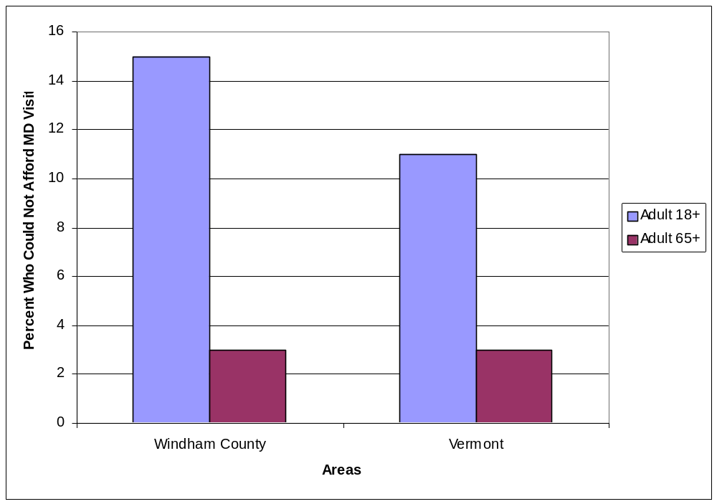Source: Vermont Department of Health, Vermont Behavioral Risk Factor Surveillance System, 2005
In addition to access to health care services, access to medications can be affected by inability to pay. Though a majority (95.4%) of survey respondents indicated that they have access to the medication they need, among those who did not have access, the exclusive reason given was because the medications were too expensive and/or they were not covered by insurance.
Availability of services can also affect access to care. Table 41 depicts the number of and practice availability of Windham County and Vermont physicians. In 2004, there were 59 primary care practices and 54 specialty practices in Windham County. Compared to the area’s population, Windham County has approximately 1 primary care practice per 752 residents, compared with 1 primary care office per 895 residents in Vermont. For specialist offices, the trend is reversed, with Vermont having 1 specialist office per 737 residents and Windham County having 1 specialist office per 820 residents.
Among both primary care and specialty practices, not all practices are open to new patients. In Windham County, 83% of primary care offices are open to new patients, and that figure is considerably less for patients covered by Medicaid (76%) or Medicare (73%). Specialty practices are less restrictive, with the only restrictions currently being placed are on those covered by Medicaid. Six percent of practices indicate that they will not accept new Medicaid patients. Statewide, the primary care figures are slightly lower, but generally follow the same pattern. Specialist offices statewide are more restrictive than in Windham County with anywhere from 5-15% reporting that they are not accepting new patients (depending upon the insurance of the patient).

Table 41: Primary Care Provider and Specialist Practice Availability, 2004
 | Windham County  (population = 44,284) |  | Vermont  (population = 621,394)
 | Primary Care offices | Specialist offices | Primary Care offices | Specialist offices
Number of offices | 59 | 54 | 694 | 843
Avg. population count per office | 752 | 820 | 895 | 737
Accepting new patients | 83% | 100% | 81% | 95%
Accepting new Medicaid patients | 76% | 94% | 71% | 85%
Accepting new Medicare patients | 73% | 100% | 70% | 87%
Source: Vermont Agency of Human Services, 2004

Health care access may also be improved when the individual is able to identify an individual as their personal medical doctor or health care provider. As noted in Figure 10, in the 2004, Vermont Behavioral Risk Factor Surveillance Survey, 88% of Windham County adults aged 18 and older were able to identify one or more individuals as their personal MD or health care provider. This percentage is higher than that of Vermont, which is 85%. For adults aged 65 and older, this rate is 95% for both the County and the State.

Figure 10: Population of Adults Identifying One or More Individuals as Personal MD or Health Care Provider, 2004
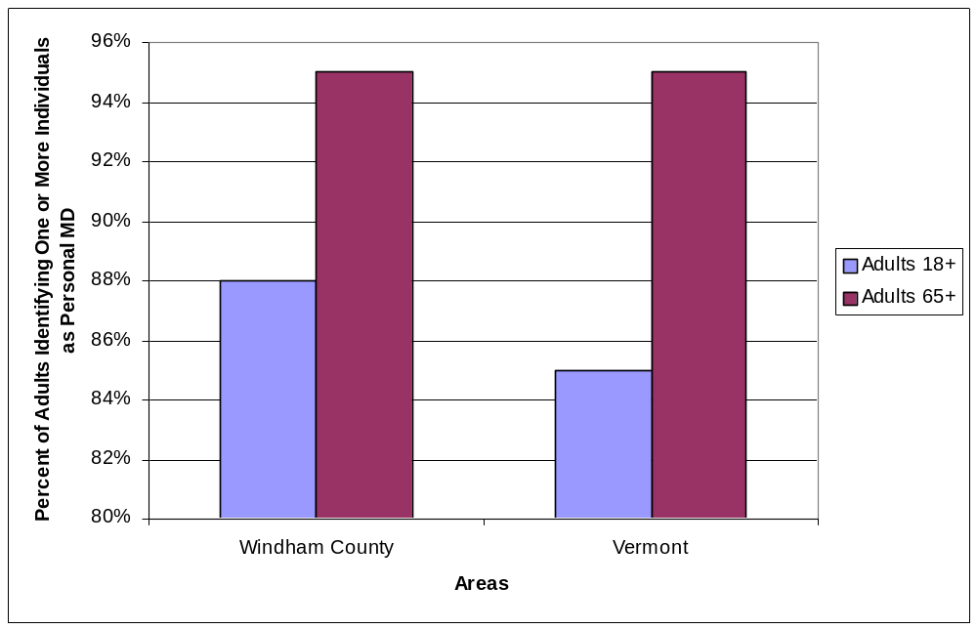Source: Vermont Department of Health, Vermont Behavioral Risk Factor Surveillance System, 2005

One of the traditional means for providing care for frail elderly and disabled individuals has been nursing homes. Since 2000, Windham County has lost approximately 179 nursing home beds due to the closing and/or downsizing of three nursing facilities. As illustrated in Table 42, in 2005, Windham County had 213 nursing home beds, in four nursing homes, a number that is expected to remain stable though 2015. Statewide, Vermont is expected to lose 369, or 12%, of its nursing home beds by 2015 (Vermont Department of Disabilities and Aging).

Table 42: Nursing Home Beds, 2005-2015
Year | Windham County | Vermont
2005 | 213 | 3,439
2015 | 213 | 3,070
Source: Vermont Department of Disabilities, Aging, and Independent Living, 2006

In general, community assessment survey respondents are concerned about the availability of health care services in Windham County. As seen in Table 43, the most important health care priority survey respondents feel needs to be addressed for Windham County seniors is improving the availability of nursing home facilities. The majority (61%) feel that increasing nursing home availability should be a high priority in the area. Focus group and interview participants cited a number of cases where individuals, with serious care needs could not have their needs appropriately met where they were living. When they requested a nursing home bed, they found that none was available for 60 or more days. Of all the priorities assessed in this study, improving nursing home access was second only to improving access to assisted living facilities. Less than 5% of survey respondents indicated that improving access to nursing home facilities should be a low priority.

An additional barrier to accessing health care, as well as human services, is a shortage of workers. With projected declines in the working age population, and dramatic increases in the over 65 population, there may be a shortage of health care and human service workers. This situation could further compound the issue of accessing services. One study by the Federal Reserve Bank of Boston, notes that in 2005, Windham County had a rate of 0.16 - 0.31 people over 85 for each woman aged 25 to 44 (the typical demographics for caregivers for individuals over 85 years old). Vermont has a rate slightly better at 0.14 – 0.16 people over 85 for each woman aged 25 to 44.

The need to improve other health care services also registered strongly among survey respondents. Almost half of survey respondents believe that improving physical and mental health services should be a high priority. Almost 40% of respondents felt that increasing the availability of emergency health and dental health services should receive the highest priority, and 34% place the highest priority on improving access to in-patient care. Improving the availability of alternative health services was somewhat less important to respondents, with 18.6% rating it a high priority.

Table 43: Health Care Priorities among Survey Respondents
 | Priority Level
Health Service | High | Medium | Low | Don’t Know
Increase availability of nursing home facilities | 61.1% | 30.1% | 4.7% | 4.1%
Improve availability of service for physical health care | 49.0% | 30.3% | 13.3% | 7.5%
Improve availability of services for mental health care | 46.2% | 32.1% | 11.1% | 10.7%
Improve availability of emergency health services | 39.1% | 34.3% | 16.1% | 10.4%
Improve access to dental services | 38.9% | 34.3% | 18.0% | 8.8%
Improve access to in-patient hospital care | 33.9% | 34.3% | 20.0% | 11.7%
Improve availability of alternative health services (yoga, acupuncture, homeopathy) | 18.6% | 29.2% | 39.4% | 12.8%

Human Services
For the purposes of this report, the Human Services section will focus on services to meet the needs of the elderly, including services to help them provide care for others or to receive services for themselves.

Providing regular care for elderly and/or disabled family and friends or grandchildren is a common occurrence among seniors. Though few survey respondents reported serious limitations on their life due to these responsibilities (see Table 44). Of the 62 survey respondents who regularly help care for an aging/disabled person, only 11.3% reported this caregiving as limiting or severely limiting. Interestingly, 12.9% of survey respondents did not know.

There are many resources available in Windham County to provide assistance to caregivers/families of elderly individuals. In reference to Table 45, survey respondents providing care for an elderly and/or disabled person reported that resources such as respite care, adult day services, hospice care, caregiver support groups, friends and neighbors, the Council on Aging, and home health services were helpful to them in their role as caregivers. For those providing care for grandchildren, survey respondents reported that family and friends, after-school programs, day care, and Head Start were useful supports to them.

Table 44: Caregiving Limitations among Survey Respondents*
 | Extent limited in past 6 months
Regularly help care for… | Severely  limited | Limited | Somewhat limited | Not limited | Don’t know
Aging/disabled person (n=62) | 1.6 | 9.7% | 30.6% | 45.2% | 12.9%
Grandchild (n=18) | 0% | 0% | 22.2% | 61.1% | 16.7%
*Actual count, rather than percentages are reported due to low cell counts.

Table 45: Caregiving Resources Reported Helpful among Survey Respondents*
Helpful in caring for elderly/disabled |  | Helpful in caring for grandchildren
Respite Care | 12 | Other family/friends | 8
Adult day services | 8 | After school programs | 3
Hospice | 9 | Day Care/Head Start | 6
Caregiver support groups | 7
Friends/neighbors | 3
Council on Aging | 3
Home health/visiting nurse | 4
*Actual count, rather than percentages are reported due to low cell counts.

In July 2005, Vermont became the first state to be awarded an 1115 Medicaid Waiver to support community- and home-based long-term care services for the elderly and disabled. The ensuing program, “Choices for Care”, was created to allow seniors and adults with disabilities to choose where they will receive their services since nursing home care is no longer the only entitlement under the program. The goal of Choices for Care is that, among individuals receiving services through the initiative, no fewer than 40% would be served in a home or community-based setting, while no more than 60% would be served through nursing care facilities. Of the 13 counties in the State, Windham is one of only seven counties that is currently providing services at this 40/60 ratio. Community members and advocates for the elderly noted that they are currently waiting for an accurate evaluation of the Choices for Care program and its impact on individual health and quality of life.

Although assisted living facilities account for a much smaller percentage of the long-term care available in Vermont, their use is expected to grow considerably from 2005 to 2015. Table 46 shows that overall in Windham County there were 42 individuals in assisted living residences in 2005. This figure is expected to grow to 71 by 2015. Statewide there are 250 individuals in assisted living, with the 2015 projection estimated at 425 individuals.

Table 46: Assisted Living Residents 2005-2015
 | Windham County (count) | Rate of Growth (%) | Vermont (count) | Rate of Growth (%)
2005 | 42 | - | 250 | -
2010 | 57 | 36% | 342 | 37%
2015 | 71 | 25% | 425 | 24%
Source: Vermont Department of Disabilities, Aging, and Independent Living

Vermont has 13 state funded and 2 non-state funded adult day service centers. Adult day services are available in Windham County at the Gathering Place in the town of Brattleboro. The Gathering Place offers social support, activities, nursing care, preventative health services, help with personal care and daily living activities, respite care, and transportation.

Even before the Medicaid waiver was implemented, the use of adult day services increased (see Figure 11). Statewide, adult day services participants increased from 702 in 1996 to 978 in 2002. Despite a slight dip to 931 in 2003, after the initiation of Choices for Care in 2005, the number once again increased substantially to 1,027 in 2004. The use of adult day services is expected to continue to grow at a rate upwards of 20% in both Windham County and Vermont over the next 10 years.

Figure 11: Total Adult Day Participants Served in Vermont
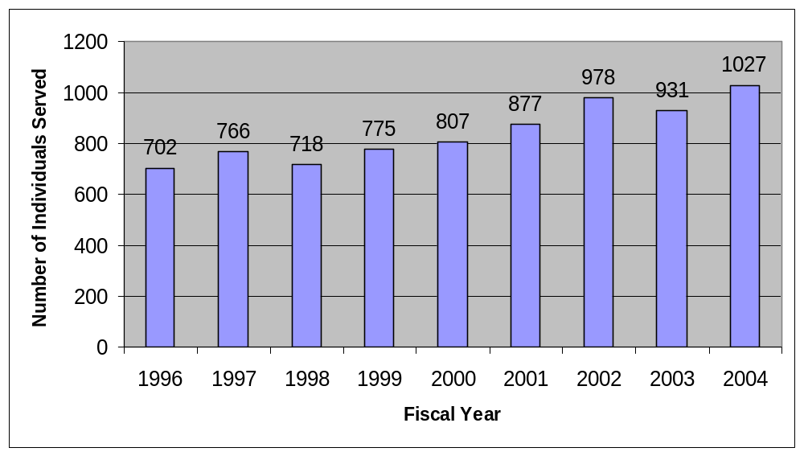
Source: Vermont Agency of Human Services

There are 12 senior centers with meal sites located in Windham County and one in neighboring Reedsburg that serve area seniors. Meal sites at two centers—the Bellows Falls Area Senior Center and the Brattleboro Senior Center—are open daily, Monday-Friday, for five hours per day and serve one meal each day they are open. All other meal sites are open limited hours, usually 1-2 times per month for a few hours at a time.

Table 47 illustrates survey respondents’ priorities for addressing human services in Windham County. Among all of the priorities for improving aging in the area that survey respondents were asked to assess, increasing the availability of assisted living facilities was the most important to respondents. Two-thirds of survey respondents (66.0%) rated increasing the availability of assisted living facilities as a high priority. This issue also had the lowest number of respondents rating it a low priority, at 4.0%.

Table 47: Human Services Priorities among Survey Respondents
 | Priority Level
Human Services | High | Medium | Low | Don’t Know
Increase availability of assisted living facilities | 66.0% | 24.8% | 4.0% | 5.2%
Increase access to legal services | 27.4% | 36.3% | 27.4% | 8.9%

In Vermont, local Agencies on Aging purchase legal services for elderly state residents, to help them with a variety of issues including wills, reporting abuse or neglect, public benefits, and housing. According to the Vermont Agency of Human Services, Department of Disabilities, Aging, and Independent Living, 2,386 people received such services in 2004. Approximately 27.4% of survey respondents felt that improving access to legal services for the elderly should be a high priority.

VISION FOR THE FUTURE OF WINDHAM COUNTY
In each focus group and interview, participants were asked to write down their vision of Windham County in five years that supports successful aging. They described a place where people are valued, respected and work together to create a community that supports everyone. The respondents’ statements generally addressed six areas: social environment, transportation, housing, part-time employment opportunities, social services, and recreation.

For a complete list of themes from the vision activity, see Appendix VII.

Social Environment

Respondents envision Windham County as a place where people of all ages help each other and share their gifts and talents. Community members are aware of and support individuals in all stages of aging and value the older community members. There are many opportunities for civic involvement, volunteering, intergenerational activities, socializing, recreation, and continued learning. Residents enjoy being engaged with their community and have access to all necessary support services as they age.

Transportation

Study respondents described increased use of public buses and other transportation services. They envision a variety of transportation choices from public transportation to vans and cars with drivers being used by community members. These services are reliable, affordable, and available during the day as well as in the early morning and evening. Transportation services are available in all communities in Windham County and are accessible to individuals with disabilities.

Individuals who choose to walk to places are utilizing well-kept sidewalks, walking paths, and parks on their journeys.

Housing

Community members envision a community with a variety of housing opportunities to meet the changing housing needs of individuals and families. These housing opportunities are accessible and affordable and allow individuals to stay in their communities as they age. All housing is designed to meet the needs of people with disabilities. New neighborhoods are created with easy access to stores, banks, houses of worship, restaurants, entertainment, and other services.

Some of the housing opportunities described include:
- Affordable rental units,
- Affordable rental units with additional services to meet the needs of the residents,
- Single story houses, closer to the center of town that allow people to ‘downsize’ from their current living situations,
- Cohousing where residents actively participate in the design and operation of their own neighborhoods with private homes and common facilities,
- Assisted living.

Homeowners are able to stay in their homes because there are services to assist them in home maintenance and management. Examples of these services include snow removal, installation of devices to prevent falls, minor home improvements, cleaning/decluttering, and yard work.

Part-time Employment Opportunities

Respondents envision increased diversity and quantity of part-time employment opportunities. These part-time jobs provide additional income for households and opportunities for older adults to continue to use their skills and expertise. Older community members are recognized as resources.

Social Services

Assessment participants described programs and services that are better coordinated, avoid duplication, and provide diverse strategies and activities to meet the varied needs of the aging population. These programs have stable funding sources and/or reasonable fees for services.

Cares groups (community-based groups that utilize volunteers to help elderly and disabled adults remain healthy and independent in their communities) are expanded and strengthened. There is a Cares group serving each Windham County community providing needed programs and services for the disabled and elderly members of their communities. They are a significant resource for keeping individuals connected to their communities, transporting them to medical appointments, and providing other services. The Cares groups provide appropriate programming and have stable funding.

There are expanded programs in the areas of adult day services, respite care, and meal delivery. Senior centers are located throughout Windham County. They provide opportunities for educational and health programs and services to be brought into communities and create more opportunities for social interaction.

Recreation

Community members described a variety of indoor recreation opportunities. These opportunities include a facility with walking track, exercise classes, a meeting area, access to refreshments, and a pool for general and therapeutic uses. The building and its amenities would be accessible for individuals with disabilities. Transportation programs would serve the facility.

RECOMMENDED NEXT STEPS

The Windham Regional Healthy Aging Steering Committee commissioned this study to conduct an assessment and create a vision of a livable and viable community for all, particularly the aging population. The information in this assessment provides a context for the creation of an action plan. There are many positive benefits of an increasing proportion of aging residents in our region. Yet, the following challenges should remain at the forefront of all planning and outreach:

- There will be a dramatic rise in the aging population in the next 15-30 years. The next generation, of smaller population size, will be asked to provide an increased variety of support for their elders.
- Increased support will require significantly greater regional contributions of time, money and other resources to cover growing support and costs associated with elders’ needs.
- This intergenerational balance of need and support will be a significant social and financial issue in the 21st century in our community and nationally.
- The current and future availability of appropriate assisted living and nursing home facilities is a matter of serious concern to a majority of county residents. While the Vermont Choices for Care program has increased the choices available for Medicaid recipients, there are inadequate resources for handling the increased regional demand for such services in the future.
- The lack of affordable and appropriate housing is a serious problem for elderly residents of Windham County. Although the State of Vermont identified housing affordability as a significant problem over twenty years ago and has taken some steps to address the issue, the problem remains as serious, or more so, than ever, and current state and federal budget constraints and priorities have resulted in reductions in funding for housing programs.
- Public and volunteer transportation in the region consists of a fragile set of scattered services to a geographically dispersed population. These services are struggling for funding just to maintain fixed route public transportation at current levels. As current trends continue, the need for such services will increase.

In light of these challenges and the data presented in this study, it is hoped that the following recommendations will continue to generate dialogue and mobilize community members to create a plan, and identify and implement effective strategies to create a livable and viable community for all, particularly the aging population. The following next steps are recommended:

Collaborative Planning
- Tap into the population’s expertise and desire for civic involvement by providing opportunities for community members of all ages, particularly the aging population, to be engaged in action planning and developing and implementing effective strategies
- Engage existing and new partners from all sectors of the community, including but not limited to health and human services, business, housing, transportation, workforce development, arts and cultural organizations, recreation and faith communities, to develop, implement and evaluate a coordinated strategic plan to meet the future needs of the aging population in the Windham County area
- Develop and implement strategies to increase the general public’s awareness and understanding of issues related to growing older in the Windham County area, including current challenges and availability of resources

Health and Social Services
- Accurately identify the current and projected shortfall in health and social services. This will require a different methodology than currently used. For example:
  - For facility care, instead of the current system of counting empty beds, determine how long eligible nursing home bed applicants, with an identified need for nursing home care are waiting for placement
  - For home based services, devise a system that provides accurate data on the need, demand and availability of services
- Increase awareness efforts about the availability of and access to primary care, mental and behavioral health, dental care and emergency services
- Encourage collaborations and partnerships to improve access to health and social services by:
    - Supporting statewide, regional and local initiatives to increase the number of health care workers and physicians
    - Supporting efforts for policy changes
- Increase awareness of and efforts to reduce elder abuse and neglect
- Increase accessibility for people with disabilities to community activities and services, including health, medical, dental and social services
- Develop strategies to address the community’s concerns around the reduction of nursing home beds. For example:
  - Identify ways to maximize the provision of services, for example, ways to expand and make better use of community care volunteers, ways to improve efficiencies in the delivery of services
  - Reexamine existing policies for prioritizing services to the most needy under any circumstances
- Partner with existing providers to expand respite care opportunities
- Partner with existing providers to expand adult day services programming, particularly in the northern and western parts of the county
- Increase the availability of assisted living facilities
- Leverage resources to increase health promotion and prevention services, among elders, particularly in the areas of:
    - Nutrition
    - Physical activity
    - Chronic disease

Transportation
- Increase awareness of and ridership for existing transportation programs and services available to the elderly
- Collaborate with transportation providers, planners, town officials, developers, realtors, bankers and the general public to identify and address barriers and impediments to increasing access to transportation services by expanding hours of service, ensuring affordability of service and expanding routes
- Advocate for changes in policy and legislation at the state level
- Create new and maintain existing and future sidewalk and walking/biking paths
- Educate stakeholders/broader community about and advocate for development patterns that facilitate use and expansion of public transit as well as improve access to home-based services

Housing
- Increase public awareness of housing related issues for aging and disabled individuals and families
- Support work with town governments, planning and zoning boards for the development of residential properties for purchase and rental
  - Increase the supply of quality, affordable housing in close proximity to retail, medical, dental and social services, schools, places of worship and places of work to increase access to these services, reduce costs of providing care at home and lessen a sense of isolation
  - Increase the availability of quality, affordable rental housing and housing for purchase
  - Encourage and support different housing models such as cohousing
  - Encourage and support housing with additional services, such as shopping and errand services, transportation, housekeeping, and social activities
- Advocate for changes in housing related policy and legislation at the state level
- Encourage the development of fee for service programs to assist homeowners with home maintenance and minor repair/improvements

Education, Employment, and Financial and Legal Services
- Collaborate with local school systems, colleges, and adult education providers to increase awareness of existing programs and services and to increase opportunities for continued learning
- Support statewide, regional and local initiatives to increase the number of health care workers and physicians in the Windham County area
- Collaborate with current employers to increase the diversity and expansion of part-time employment opportunities
- Improve access to and availability of legal and financial services, including retirement and estate planning and budget management, for individuals as they age
- Provide educational opportunities for caregivers and families on financial and legal issues that impact an older person’s life

Recreation
- Increase awareness of and access to existing recreational programs
- Support existing initiatives to establish indoor recreational opportunities in Brattleboro and Springfield
- Create and support new initiatives for indoor and outdoor recreational activities and resources such as:
    - Strength training programs
    - Pools
    - Walking tracks
    - Art programs (painting, quilting, photography)
    - Group fitness programs
    - Walking paths
    - Biking paths

Appendix I: Advisory Group

Lynn Bedell, The Gathering Place
Janet Cramer, Private Practice Therapist
Jenny Gelfan, Council on Aging for Southeastern Vermont
Kendall Gifford, Windham Regional Commission
Christine Hart, Brattleboro Housing Authority
Joyce Lemire, Council on Aging for Southeastern Vermont
Andrea Livermore, United Way of Windham County
Mary Oberly, Visiting Nurse Association for Vermont and New Hampshire
Susan Parris, Brattleboro Area Hospice
Adrian Segar, United Way of Windham County, Board
Edith Serke, Council on Aging for Southeastern Vermont, Board

Appendix II: Sources of Secondary/Existing Data

- Claritas

- Ethan Allen Institute

- Freddie Mac

- New York Public Interest Research Group

- U.S. Bureau of Labor Statistics

- U.S. Census Bureau

- U.S. Centers for Disease Control and Prevention

- U.S. Department of Justice

- United Health Foundation

- Vermont Agency of Human Services

- Vermont Department of Children and Family

- Vermont Department of Disabilities, Aging and Independent Living

- Vermont Department of Health

- Vermont Housing Finance Agency

- Vermont Department of Housing and Community Affairs

- Vermont Department of Labor

- Vermont Department of Taxes

- Vermont Housing Finance Agency

- Windham Regional Commission

Appendix III: Windham County Community Survey

Thank you for taking the time to complete this questionnaire. We assure you that your answers will be kept confidential.

We would like you to answer as many questions as possible, but if there is a question that you are not comfortable answering please leave it blank and go on to the next question.

First, we’d like to ask you some general information. Please answer the following questions by either filling in the blank or checking the box.

- Do you live in Windham County?
No……Please describe your connection to Windham County:____________________________________
Yes…..For how many years? _____

- In what town do you currently live? ___________________town
- In what year were you born?
________ Year born
- What is your gender?
Male Female
- Which of the following best describes your race?
Asian/Pacific Island Black Native American White
Mixed Other
- Are you Hispanic/Latino?
No Yes
- What is your marital status?
Single Married Divorced Separated Widowed Other
- Are you presently employed?
No
Yes: part-time Yes: full-time
If yes, what is your occupation/s? __________________________
- Have you retired?
No……At what age do you think you might retire? _____years
Yes…..At what age did you retire? _____years. What was your occupation?___________________

- In the past year, have you worked as a volunteer?
No
Yes…..On average, how many hours a month? _____
Our next questions are about health and care-giving responsibilities. Please remember that if you are not comfortable answering a question, leave it blank and go to the next question
Health
11. What kind of health insurance do you have? (Check all that apply).
None Medicaid Medicare Medi-gap Self-pay
Private, like BCBS, MVP or Golden Rule Other: Please describe_____________
12. Do you have a regular medical practitioner (e.g., physician, nurse practitioner, physician’s assistant)?
No
Yes
13. Do you have a regular dental practitioner?
No
Yes
14. Do you use any alternative therapies (acupuncture, homeopathy, massage, chiropractic, herbal)?
No
Yes

- Are you able to obtain the medications that you need?
Yes
No…. If no, why not? Please check all that apply
Cost of medication
Medication not covered by my insurance
Lack of transportation
Pharmacy not open at times convenient to me
Pharmacy does not carry the prescription drug I need
Other, please explain:

- In the last five years, have you or someone you help (friend, relative, client) tried to obtain a nursing home placement?
No
Yes If yes, how long was the wait?
No Wait
Less than one week
One week to a month
Between one and six months
More than six months
Never was able to obtain a placement
- In the last five years, have you or someone you help (friend, relative, or client) tried to obtain needed professional health assistance at home?
No
Yes If yes, how long was the wait?
No Wait
Less than one week
One week to a month
Between one and six months
More than six months
Never was able to obtain a placement
- Would you say that in general your health is:
Excellent Very good Good Fair Poor
Caring for Other Adults/Children
- Do you regularly help care for an aging person or other person such as a spouse, parent, in-law, child with disabilities, other relative, friend or neighbor?
No {Go to Q24}
Yes {Please answer Q20 – Q23}

- How many individuals do you help care for? ________
- What are their relationship(s) to you, check all that apply.
Son or Daughter
Spouse
Parent or In Law
Disabled Child
Friend/Neighbor

- During the past six months or longer, to what extent have you been limited in doing activities people usually do because of the care you provide to an aging person or persons?
Severely limited Limited Somewhat limited Not limited Not applicable
- What resources/services particularly help you with the care-giving you provide to the aging person/s? Check all that apply
Respite Care (volunteer comes in and gives caregiver a break)
Adult Day Care
Hospice Program for Terminally Ill
Caregiver Support Groups
Other
Caring for Grandchildren
- Do you regularly help care for your grandchild or grandchildren?
Yes {Please answer Q25 - Q26}
No {Go to Q27}
- To what extent are you limited in doing activities people usually do because of the care you provide to your grandchild or grandchildren?
Severely limited Limited Somewhat limited Not limited Not applicable
- What resources/services particularly help you with the care-giving you provide to your grandchild/grandchildren?
Other family members
Neighbors
Day care
After school programs
Other _______________________
Transportation
- Do you drive a vehicle for personal needs?
Yes – drive in daylight and at night
Yes – drive in daylight only
Stopped driving - At what age? ______
Never drove
- Below is a list of transportation options. Which do you regularly rely on to get yourself to places you need to go? Check all that apply.
Walking Riding my bicycle
My own personal vehicle A friend/neighbor drives me
Taxicab
A volunteer drives me (For example, a volunteer from a Cares Organization)
Public Transportation (CRT, Moovers)
Bus/Van run by facility where I live
Other, please list: _______________________
- Do you have any challenges getting to places you need to go?
No
Yes: Please describe________________________________________________________

Housing

- What best describes the home you live in?
Own Rent Live with relative Other
- Do you live with a spouse/partner?
No Yes
- Please check all that apply to you:
Live in own home Live in an assisted living facility
Live with a relative Live in a nursing home
Live in senior housing
Other: Please describe:_____________

- Are your living accommodations adequate for your current needs?
Yes
No: Please describe:__________

- Are your living accommodations affordable?
Yes
No Please describe:_____________________

- Do you have any concerns about your living accommodations within the next 5 years?
No
Yes: Please describe:___________________

- What is the likelihood you will move away from Windham County, but stay in Vermont, in the next 5 years?
Very likely Likely Somewhat likely Not likely Don’t know
If there is a likelihood you will move out of Windham County but stay in Vermont, what would the reason be?
- In the next five years, what is the likelihood you will change living accommodations, but still be in Windham County in the next 5 years?
Very likely Likely Somewhat likely Not likely Don’t know
If there is a likelihood you will move within Windham County, what would the reason be?
- What is the likelihood you will move away from Vermont in the next 5 years?
Very likely Likely Somewhat likely Not likely Don’t know
If there is a likelihood you will move out of Vermont, what would the reason be?
Our next questions are about finances. Please remember that if you are not comfortable answering a question, leave it blank and go to the next question
Finances
- a) What best describes your household income from all sources for the year 2005?
less than $10,000 $10,000 - $14,999 $15,000 - $24,999
$25,000 - $34,999 $35,000 - $49,999 $50,000 - $74,999
$75,000 - $99,999 over $100,000
b) How many people does this income support? ______ people
- What are your current sources of income? Check all that apply.
Wages Retirement Savings (IRA, 401K, 403B)
Social Security Savings
Pension Other
- In the past year, have you had difficulty paying for any of the following items? (Please check all that apply)
Housing Housing repairs Utilities; e.g., gas, electric, home heating
Transportation Health insurance Medical bills; e.g., doctors & hospital
Medicines Food Clothing
Gas for a vehicle None

42. What priority should be given to the following issues for making Windham County a community that supports successful aging?

In Windham County …. | High Priority | Medium Priority | Low Priority | Don’t Know
- Increase opportunities for continued learning
- Increase opportunities for intergenerational activities
- Increase opportunities for older community members to volunteer
- Increase opportunities for older community members to participate in civic activities
- Expand opportunities for employment
- Improve access to food stores
- Improve access to clothing and retail stores
- Increase access to places of worship
- Improve transportation services
- Improve the availability of services for physical health care
- Improve the availability of services for mental health care
- Improve the availably of emergency medical services
- Improve access to in-patient hospital care
- Improve access to dental services
- Improve the availably of alternative health services (yoga, acupuncture, homeopathy)
- Increase the availability of quality, affordable rental housing
- Increase the availability of quality, affordable housing for purchase
- Increase availability of services to help older individuals take care of their homes (i.e., cleaning, maintenance, lawn mowing, snow removal)
- Increase availability of assisted living housing units
- Increase availability of nursing home facilities
- Develop more opportunities for indoor recreation
- Develop more opportunities for outdoor recreation (i.e. walking, biking, birding, canoeing)
- Develop more opportunities for entertainment
- Increase access to libraries
- Increase opportunities for socializing with other older adults
- Improve access to the internet and e-mail
- Increase access to services for financial planning
- Increase access to legal services

43. Windham County is a good place to grow older.
Strongly agree
Agree
Disagree
Strongly disagree
Don't know

44. Do you have any additional comments about creating a livable and viable community that meets the needs of the aging population? Please list them here.

Appendix IV: Windham County Area Survey Summary Tables

Select Demographic Characteristics of Survey Respondents
Gender |  | Female  Male | 70.0  30.0
Race/Ethnicity |  | White  Native American  Mixed Race  Other  Identified as Hispanic/Latino | 98.8  0.3  0.6  0.3  0.7
Marital Status |  | Single  Married  Divorced  Separated  Widowed  Other (nature not identified) | 12.6  48.6  13.8  .6  21.8  2.5
Age | Mean  Median  Range |  | 67.0  68.0  22,97
Annual Household Income  Sources of Income  Number of people supported by income | <$10,000  $10,000-$14,999  $15,000-$24,999  $25,000-$34,999  $35,000-$49,999  $50,000-$74,999  $75,000-$99,999  >$100,000  Wages  Retirement savings  Social security  Pension  Savings  Other  Mean  Median  Range |  | 18.2  12.4  13.2  10.1  9.7  17.4  11.6  7.4  36.0  19.8  61.6  30.5  23.5  14.3  2.0  2.2  1,6
Retired  Average retirement age | Yes  No  Mean  Median  Range |  | 61.4  38.6  61.5  62.0  34,95
Employment  Age expect to retire | Full-time  Part-time  Not employed  Mean  Median  Range |  | 24.5  15.2  60.4  66.6  66.0  55, Never
Number of Years in Windham Region | Mean  Median  Range |  | 35  30  1,92
Type of Living Accommodation | Own home  Senior housing  In relative’s home  Assisted living  Nursing home  Other |  | 66.2  22.6  7.9  .6  .3  1.8
Drive  Form of transportation used | Yes  Yes, only in daylight  Stopped driving  Never drove  Drive own car  Walk  Friend/neighbor drives  Public transport  Bus/van at facility where live  Bike  Family drives  Taxi  Volunteer drives  Other form |  | 70.2  9.5  10.5  9.8  72.0  20.5  13.4  10.7  7.3  7.2  5.2  4.9  2.7  3.0
Volunteered in Past Year  Number of Hours Volunteered | Yes  No  Mean  Median  Range |  | 60.2  39.8  13.4  10.0  1,90

Distribution of Survey Respondents among Towns in Windham County
Brattleboro | 43.9
Rockingham | 11.9
Westminster | 10.7
Dummerston | 4.9
Putney | 4.0
Wilmington | 4.0
Guilford | 3.0
Grafton | 2.9
Marlboro | 2.7
Townshend | 2.2
Athens | 1.2
Vernon | 1.2
Whitingham | 1.2
Newfane | 0.9
Brookline | 0.6
Halifax | 0.6
Jamaica | 0.6
Wardsboro | 0.6
Windham | 0.6
Dover | 0.3
Jacksonville | 0.3
Readsboro | 0.3
Williamsville | 0.3
No response | 1.8

Social Services, Caregiving among Survey Respondents
Tried to obtain placement for self or someone they help (friend, relative, client, etc) in nursing home in past 5 years  Length of wait to obtain nursing home placement | Yes  No  No wait  < 1 week  1 week - 1 month  1 - 6 months  > 6 months  Never obtained placement | 16.7  83.3  30.0  18.0  26.0  18.0  4.0  4.0
Tried to obtain professional home health assistance in past 5 years  Length of wait to obtain professional home health assistance | Yes  No  No wait  < 1 week  1 week - 1 month  1 - 6 months | 27.7  72.3  44.9  23.1  25.6  6.4
Provide regular care for…  Number of elderly/disabled persons help care for | Elderly/disabled person  Grandchild  1  2  3  4 | 18.5  5.8  67.3  23.6  7.3  1.8
Health Insurance | Uninsured/pay out of pocket  Medicaid  Medicare  Medigap  Private  Other insurance | 4.9  16.8  53.4  10.1  52.4  8.5
Health Care | Have a regular medical provider  Have a regular dental practitioner  Use alternative therapies | 97.2  75.3  31.9

Appendix V: Interview and Focus Group Guide
Welcome and Introductions (10 min.)
Introduce self and describe role, have recorder introduce his/herself and describe role

Ask participants to introduce themselves and to share how long they have lived/worked in Windham County.

Overview & Rationale (2 min)
The goal of this project is to compile the qualitative and quantitative data necessary to inform the development of a plan to support healthy aging and to meet the continuing needs of an aging population in Windham County. The plan will be based on an analysis of state and local data including an assessment of the assets, needs, perceived preferences and available resources within the region. A community environment that supports healthy aging must include opportunities for social contact and housing, transportation, ready access to stores, places of worship, libraries, recreation and entertainment and the full range of health services.

Purpose of Meeting (2 min)
1. To collect information from interviewees/participants on their understanding of community assets, issues and priorities, gaps and resources related to healthy aging in Windham County

2. To create a vision that will guide the development of a plan based on qualitative and quantitative data to support healthy aging in Windham County.

Review Group Agreement (2 min)
Introduce guidelines for the group. Ask if any participant would like to add additional items.
- Sharing of Ideas
- Respectful Listening
- Holding of Judgment
- Confidentiality
- Respect for Time

Introductory Exercise (25 min)
Assess the age of the group and adjust questions, as appropriate. Participants may use their own definitions for ‘healthy’ and ‘frail’.
- Imagine you are in your 70’s or older and you are healthy and living in Windham County. Take a minute to think about what your life is like or would be like. What is your day like?
Allow for a moment or two of silence for participants to think about their responses.
- Join with a partner and take 2 minutes each to share your response to each of the following questions.
a) What is the best thing about growing older in Windham County?
b) What is the most difficult thing?
Ask participants who are willing to share their answers. Write key words on newsprint if possible (3 min)

- Now imagine that you are in your 70's or older and you are frail and living in Windham County. Take a minute to think about what your life is like.
Allow for a moment or two of silence for participants to think about their responses.
- Join with a partner and take 2 minutes each to share with each other your response to each of the following questions.
a) What is the best thing about growing older in Windham County?
b) What is the most difficult thing?

Ask participants who are willing to share their answers. Write key words on newsprint if possible - Ask for group to reflect on these responses and share their thoughts.(3 min) Now ask group to consider the following questions.

Questions (50 min)
Introduce this portion of the focus group by explaining to participants that the questions are about assets, issues/challenges, resources and gaps. Adjust language to meet the needs of the group.
1. What are the assets (people, places, things) in Windham County that make Windham County a good place to live as you are aging?

2. What are the issues/challenges in Windham County that may make it a more difficult place to live as you are aging?
(If interviewee or focus group does not address issues related to transportation, housing, support services and health/ medical services, educational and cultural opportunities, entertainment and recreational opportunities please ask if they have any issues related to any of the above areas that they have not addressed.)

3. What are the current resources that support healthy aging in Windham County?

4. Where are the gaps?

5. What is your vision of a Windham County that supports successful aging? Activity:
Imagine that it is 5 years from now. Community members, and maybe you, have been successful in efforts to create a community in Windham County that supports successful aging for the healthy and the frail, what does it look like?
- Give each participant a blank piece of paper and a pencil
- Allow a few minutes for the participants to think about the question and write/draw their response to the question on paper - use present tense.
- Ask participants to share a thought.
- Summarize.
- Collect participant's visions.

6. Do you have any additional comments/reflection?

7. Who else should we be talking to?

Thank you for taking the time to participate in this focus group/interview.

Next Steps - (5 min)
- Compile data from interviews, focus groups, and existing data. Individual information will remain confidential.
- Survey community members.
- Analyze data and develop a preliminary report and present to the Advisory Group.
- Conduct community meetings to share findings and discuss strategies with community members.

Appendix VI: Interview and Focus Group Participants

Name |  | City/Town
Patricia | Akeley | Brattleboro
Beverly | Alberts | Brattleboro
Sally | Andrews | Marlboro
Joe | Armstrong | Brattleboro
Arthur | Avery | Dummerston
Janet | Avery | Dummerston
Joyce | Ballantine | Jamaica
Carol | Barry | Brattleboro
Lynn | Bedell | Brattleboro
Henry | Belisle | Bellows Falls
Scott | Belt | Brattleboro
Lisa | Bergeron | Brattleboro
Regina | Borden | Saxtons River
Darcy | Brown | Brattleboro
Tom | Buchanan | Bondville
Hannah | Bucossi | Brattleboro
Lynne | Buehler | Grafton
Jen | Carroll | Brattleboro
Caitlin | Cheslawski | Brattleboro
George | Clark | Brattleboro
Gladys | Clemens | Brattleboro
Mildred | Coe | Bellows Falls
Janice | Cominoli | Townshend
Tom | Consolino | Wilmington
Wendy | Cornwell | Brattleboro
Sue | Cota | Saxtons River
Janet | Cramer | Brattleboro
Robert | Crego | Townshend
Rose | Cretelle | Bellows Falls
Marion | Crosby | Bellows Falls
Ruby | Cushman | Saxtons River
Richard | Davis | Guilford
Susan | Davis | Guilford
Fran | DeFlorio | Brattleboro
David | DeFossess | Brattleboro
Pat | Dion | Bellows Falls
Kate | Dodge | Putney
David | Dunn | Brattleboro
Ray | Enello | Dummerston
Judy | Enello | Dummerston
Virginia | Ferguson | Bellows Falls
Jennifer | Fitzgerald | Wilmington
Ruth | Fleming | Brattleboro
Peggy | Floume | Jamaica
Kay | Frazer | Saxtons River
Marie | Frenette | Bellows Falls
Ronnie | Friedman | Westminster
Jenny | Gelfan | Springfield
Harriet | Gelfan | Brattleboro
Frankie | Gibson | Brattleboro
Kendall | Gifford | Brattleboro
Lucy | Gratwick | Marlboro
Elizabeth | Greentow | Putney
Michael | Gregg | Guilford
Betty | Haggerty | Bellows Falls
Christina | Haggerty | Springfield
Jennifer | Hale | Brattleboro
Pete | Harrison | Westminster
Christine | Hart | W. Brattleboro
Gerry | Harty
Kathy | Holloway | Brattleboro
Ellen | Howard | Bellows Falls
Amy | Howlett | Grafton
Richard | Jackson | West Townsend
Linda | James | Bellows Falls
Robyn | Jenks | Putney
Kay | Johnson | Bellows Falls
John | Kristensen | Brattleboro
Emily | Kunreuther | Marlboro
Peg | Larsen
Jim | Larsen
Joyce | Lemire | Springfield
Andrea | Livermore | Brattleboro
Catherine | Lowery | Brattleboro
Caren | MacDonald | Wardsboro
James | Matteau | Brattleboro
Janice | Melin | Brattleboro
Elaine | Meyer | Townshend
Helen | Miller | Rockingham
Lori | Miller | Westminster
Dick | Miller | Westminster
Joyce | Miller
Sandy | Morrison | Grafton
Judy | Morton | Putney
Jordan | Mosher | Saxtons River
Elaine | Murray | Jamaica
Mary | Oberly | Brattleboro
Ann | O'Sullivan | Wilmington
Patti | Paguette | Brattleboro
Lynwood | Paine | Bellows Falls
Susan | Parris | Brattleboro
Darlene | Perkins | Brattleboro
Shirley | Perkins | Dummerston
Jean | Pett | Brattleboro
Karen | Podsiedick | Brattleboro
Gloria | Priest | Putney
Julie | Prybylo
Bridget | Reynolds
Bess | Richardson | West Dummerston
Charlie | Richardson | West Dummerston
Germaine | Romano | Bellows Falls
Romey | Romano | Bellows Falls
Valerie | Rooney | Grafton
Elaine | Scott | Townshend
Adrian | Segar | Marlboro
Jeanne | Semonite
Edith | Serke | Windham
Joyce | Sheehan | Brattleboro
Laura | Slade | Townshend
Ed | Smith | Brattleboro
Barney | Smith
Edith | Snide | Bellows Falls
Jean | Stone | Townshend
Candace | Stoumen | Brattleboro
Caroline | Szuch | North Walpole
Marian | Taschereau | Brattleboro
Lucy | Taylor | Bellows Falls
Barbara | Ternes | Bellows Falls
Lynn | Thayer | Saxtons River
Larry | Therien | Chester
Anne | Tobey | Dummerston
Marie | Waite | Brattleboro
Karen | Walter | Putney
Frank | Walter | Westminster
Gaynol | Wapotich | Brattleboro
Jean | Ward | Brattleboro
Debbie | Waryas | Brattleboro
Jeanette | White | Putney
Dianna | Wichland | West Townsend
John | Wilcox | Dummerston
Cindy | Wilcox | Dummerston
Susan | Wilkins | Bellows Falls
Debbie | Williams | Brattleboro
Julia | Williams | Brattleboro
Jennifer | Wilson | Brattleboro
Margaret | Wimberger | Williamsville
Kate | Wolff | Brattleboro

Appendix VII: Vision Statements from Focus Groups and Interviews

- Local town collaboration for senior housing, assisted living and nursing care. Say 2 to 5 towns.
Central recreation centers that could provide activities for all ages – therapeutic to active.
There would be scheduled transportation to these centers and people could spend all day or several hours.
Adult day services
Swimming
Exercise
Education classes
Café – coffee shop
Trips to museums or parks
Information to resources
Cares groups in each town

- A series of senior centers (3-4) scattered throughout Windham that would be part nursing home, assisted living quarters and unassisted living quarters. Each would be a self-contained facility with such services as a general store, recreation center, medical clinic and park. Transportation would be provided by vans. Rent would be on a sliding scale according to income.

- Have more options for “continuing care” housing/services.
- downsizing
- moving in increments: assisted living…skilled care
- must be affordable
Public transportation: accessibility/affordability
Enrichment opportunities
- education
- recreation
- arts
Access to shopping/medical
Multiaged programs
- older people can be stimulated by interaction with youngsters

- - Affordable housing for seniors, be it single house or condos, community living
- Public transportation available on more than main routes
- Monthly activities held in various places in the community for seniors
- Classes are available, art, photography, etc.
- Bus trips
- Hiking groups for people who are able to participate
- Bird watching

- - Single story senior housing
- Transportation, adequate to shopping, medical facilities
- Organizations like Westminster Cares that have the funds to provide rides, companionships, visitation, assistance with fuel, utilities, and other homeowner problems
- Networks for support

- - More affordable housing with parking nearby
- A transportation system on a better schedule
- More part-time jobs for the elderly that need extra income but not strenuous
- More senior adult activities such as painting and quilting

- A successful community for aging-in-place (part of any goal in aging) will have created a variety of housing options, so, I wish, I could live in a separate house near others, with snow removal, general maintenance chores, heating/cooling costs, etc. Shared with like-minded but independent neighbors. There would be a central coordinator to whom I could go to volunteer services and/or ask for them on a fee for service basis. For those unable to pay the fees there would be a rotating endowment fund to meet needs not covered by governmental services. Transportation, via bus and private car would be available, especially with volunteer drivers earning stipends.

- Village centers have shops and services that meet peoples’ basic needs. There are walk able-have natural areas-and if in more rural areas have regionally scheduled transportation to the more populated centers. Offer the ability for co-hosing and other “downscaled” living options, so people can live closer together and support one another longer. This mini population center also offers efficiencies to service providers cutting down on the miles necessary to travel to clients homes. Zoning regulations that support alternative living that is appropriate for the elderly.

- - Affordable housing
- Accessible housing
- reliable, affordable transportation
- Method of coordinating required services, that makes them more affordable and useful
- Places to exercise and walk
- Accessible sidewalks in communities
- Organized volunteer networks
- Universal health care
- Opportunity for intergenerational activities

- - Each town has plan that adopts recommendations from this assessment
- One organization that has a paid staff position focusing on startup and getting established innovative plans to make Windham County healthier
- There is a park and walking trails near downtown areas
- There are co-housing units available for all income levels and age levels
- Public transportation is invested in and single care driving is discouraged
- Downtown – Main Street is car free like Church Street in Burlington or Pearl Street in Boulder
- The health care cooperative is up and running and used by a majority of citizens
- A public education campaign continues on the value and benefits of aging

- - Creation of a county wide resource that can respond to upcoming challenges in the region/explore creative ideas/work on implementing innovative program that meet our needs
- Support the expansion of Cares programs
- A serious push to explore ways that affordable, appropriate housing is made available for the community
- Easily accessible transportation
- Affordable housing with sliding scale taxes for elderly/disabled/fixed income individuals
- Volunteer opportunities that are meaningful (AmeriCorps, tutoring, mentoring) Use of the wisdom of the elderly
- Education for delivery/service people (gas, meter readers, mail delivery, taxi drivers, bus drivers) – what are the signs of change and causes for concern with regards to elders. It should be part of wrap around services to ensure quick, responsive system.

- - A variety of housing options from “living in a drafty old house but resident has somebody to call” to “manage situation all under one roof – multiple buildings or one building.”
- Covered, outdoor space
- “Intentional community” – community of houses created a community of peoples who are compatible, shared things – lawn equipment, bicycles, garbage, diversity of ages, multiple skills within the community that support the community

- Affordable housing for everyone

- A productive social life for seniors.

- Conveyor belts- better access of services to seniors and seniors to services

- Better funding to support people staying at home

- More community awareness of what the needs are to encourage neighbors to volunteer to help. If people were more aware they’d help each other out.

- Pooling resources to avoid duplication and waste to increase resources to more people.

- Improved job status for direct care workers, and better pay

- Small senior housing units in small towns

- More community based activities- indoor pool, affordable recreation, matinees at theaters

- Medication discounts

- Universal health care

- Raising income level for middle class so they receive necessary services
    - Very rural areas have a van with a nurse practitioner (clinic on wheels).
- Caregivers encouraged to take care of themselves and avail themselves of support (respite)

- Sufficient resources and support for seniors to stay at home

- Decreased taxes- tax relief for seniors

- Re-establish railroad service and other options less car dependent options

- Drop-in day time programs; with nurse, personal care, day time theater, perhaps with a pre-school attached.

- Lots of programs in rural areas

- Better food for all

- Affordable housing.

- Self contained community includes on-site meal plans, medical staff, and transportation to and from activities that runs on a regular schedule (i.e. hourly). Housekeeping if needed. Errand services, grocery, medical needs. Financial services. Community garden. Social activities. Soundproofing between apartments in senior housing. All utilities included in senior housing (cable, phone).

- I would think I was in heaven for sure if all the discussed problems were fixed. It would be a pleasure to get up every morning and see a beautiful world out there without all the clouds distorting the real world.

- Clean smooth sidewalk. No one without proper care at home. Phone surcharge dropped. Medicare and Medicaid pay all elderly medical bills. Transportation anywhere, at any time, free for elderly. Meals of choice delivered to elderly shut-ins. free trip, concerts, theater, movies for elderly.

- The elderly have a nice, warm place to live. Enough food, things to do. Good health care. Good friends and family.

- All the elderly will be living in good housing, with help if they need at any time just for the asking. No one will be turned down. If they get sick or disabled, there will be sufficient care in nursing homes for everyone. No mater how much money they have or don’t have.

- My vision for Windham County aging population would be not to be living in fear of catastrophic events—does that mean finding alternative energy sources? Does that mean closing down VT Yankee? I dream of having some homes down by the Connecticut River (I am now in Brattleboro) and Wantastiquet Drive has been made into a loop of group homes—all with a view of the river and mountain—the air is pure and clean, the water is pure and drinkable, and the ‘complex’ or whatever it would be called would be a place for elders and frail folks to feel like it was a place that was their home. It would be staffed by exceptional people—and it would be a Caring Community of Elders.

- Transportation to and from each apt. Laundry perhaps and deli. Everyone has his or her own parking space. Indoor shuffleboard, large entertainment room. Indoor swimming pool, sauna, all utilities included (phone and cable).

- There is affordable housing, with transportation, stores, sidewalks, and community services, healthcare, recreation.

- There is a continuum of care/services, including small, volunteer assistance.

- There is an annual census of older people to track their condition/needs.

- Older persons are recognized as a resource.

- There are intergenerational activities

- There is an awareness of people’s needs.

- There are regular get-togethers of older citizens.

- 1) A complex of small cottages with an assisted living building, a nursing home and a community building; 2) A building with exercise equipment and a chat room, pool and area to play cards, etc, a comfortable spot for when you need company; 3) Affordable assisted living units with a club house and clinic (example - volunteer musicians could offer to come in and do their practice sessions); 4) an affordable day care place for young struggling mothers; 5) Everybody contribute to a trust fund so that children could go to college; 6) need more young people to do volunteer work; and 7) people that would take elderly people that no longer drive for a ride on Sunday afternoons to get them out.

- Respect for aging

- Aging – making the plan

- Financial planning

- Gray Panthers

- - More senior housing
- More public transportation
- Council on Aging office in town
- Home for people who need help – nursing homes, assisted living, etc.

- - The tax rate would be so high that no one can stay here.
- More places to eat but not pizza.

- - Programs at high school with seniors tell stories
- Hourly bus routes
- Daily programs for seniors to attend

- - Sidewalks are fixed
- Businesses are handicapped accessible
- Senior Center has grown in membership
- Recreation center is build and used by seniors for walking and swimming
more businesses move into region and taxes become less burdensome.
- Fuel goes down in price or stabilizes.

- - Grocery store/supermarket
- Hospital
- Wheelchair accessible restaurants
- Recreation Center
- Parks Place
- Nursing Home(s)
- More wheelchair access
- More jobs

- - Transportation – door to door on demand, in evening as well as daytime
- Improved communications to the elderly – telephone trees and ways to connect on a regular basis to people who are isolated
- A new recreation center for the town with easy access for the elderly – indoor pool, waling track, snack bar
- Supermarket in town with reasonable prices
- Improved care for seniors – assisted living, nursing home, hospital

- - Improved transportation system
- Medical and dental services available to all
- Handicapped availability for all public places
- More resources (financial) available to such services as Senior Centers, VNAs, social service centers
- Food stores, locally

- - A shopping center
- Good medical resources
- Accessible restaurants
- Dental and eye care plans
- Jobs
- Transportation
- Recreation Center with wheelchair access

- - Hospital
- Shopping center
- More handicap accessible places
- Part-time jobs

- - Continue to live in their own individual, possibly isolated, home but with services making it possible to live there alone
- “Co-housing” situation at different levels – all under one roof with a manager but each an individual apartment or room or several individual houses or attached buildings all sharing some facilities, etc.

- - Small communities have affordable, accessible housing with easy access to stores, banks, church, etc.
- Have network (listing) of people who could help with small chores that need doing either volunteer or very inexpensive
- Cares groups have progressed to point of being able to provide all needed services to those who need and want them

- There is intentional community.
- A group of people plan to build houses in close proximity some share houses, some don’t but they all share resources such as lawn mowers, snow blowers, garbage disposal, gardening, recreation (maybe community bicycles or even motorcycles)
- Also share the human resources they have (retired health professionals, plumbers, carpenters, car mechanics, teachers) as well as young people who are working in the community

The 2000 Census family household figures do not include couples in civil unions or married, same-sex couples because the laws on civil unions and same-sex marriages were enacted after the Census was conducted, on April 1, 2000.

